Module 1: Intro to Sustainable Energy for Development

Chapter 1.0: Module 1 Introduction

Lesson 1.0.-1: Module 1 Preface
M1: Introduction to Sustainable Energy System Transformation
Welcome to the Sustainable Energy Academy!
The Sustainable Energy Academy is a training and knowledge-exchange mechanism developed by the United Nations Development Programme (UNDP) to support the transition to sustainable energy worldwide.
The Sustainable Energy Academy aims to create concrete impact on the ground by providing countries with tailor-made capacity building and a strong global community of experts and practitioners on energy as an enabler for development.
The Academy will connect energy for development 💬️ with nexus topics such as social protection and employment, policy and governance, climate change, energy security, gender equality, finance, technology and data, water management and food resilience.

Lesson 1.0.0: Module 1 Introduction
Module
Introduction to Sustainable Energy System Transformation
Module 1 Overview
Module 1 presents a comprehensive overview of the energy landscape, framed within the global development agenda. It defines and explores interconnected concepts of sustainable energy with global challenges such as climate change, fossil fuel dependency, energy poverty and disparities and opportunities, such as local development, economic growth and energy security.
This module also assesses progress towards achieving Sustainable Development Goal (SDG) 7 while exploring SDG 7’s critical interlinkages with other SDGs. The module seeks to equip readers with approaches, methods and tools for SDG7 acceleration and innovation.
Learning Objectives
Understand the concept of sustainable energy and its link with sustainable development, as well as the critical paradoxes and dilemma at the core of our energy systems.
Identify opportunities for synergies presented by the intersection of the Sustainable Development Goals (SDGs) and the Sustainable Energy-for-Development pathways.
Develop strategies for building effective partnerships and leverage approaches, methods and tools for accelerating the energy transition.

Chapter 1.1: Chapter 1: Introduction to Energy Systems

Lesson 1.1.0: Chapter 1 Introduction
Chapter
Foundations of Sustainable Energy for Development
M1: Introduction to Sustainable Energy System Transformation
Chapter 1 Overview
Energy is the silent force behind stable societies—powering systems, enabling services, and unlocking opportunity. Without it, the promise of the SDGs remains out of reach. Even small gains in access can radically transform lives, especially in the Global South.
To understand how energy shapes our world, this chapter introduces a visual map of global energy flows, showing how energy moves from sources like fossil fuels and renewables to the sectors that depend on them.
At the heart of the chapter is the ‘energy trilemma (security, equity, sustainability)’—the delicate balance between fueling economic growth while reducing greenhouse gas emissions. As global energy demand surges, fossil fuel consumption continues to rise, widening the gap between countries with abundant resources and those struggling with access. This imbalance has serious consequences, particularly in accelerating climate change, with energy use responsible for about 75% of greenhouse gas emissions (IEA, 2023).
The path forward is sustainable energy. Recognizing this urgency, COP28 set a global goal to triple renewable energy capacity and double energy efficiency 💬️ by 2030 as key steps toward achieving the Paris Agreement targets. By unraveling these interconnected issues, this chapter lays the groundwork for understanding how energy systems work and why transitioning to sustainable energy is crucial for our shared future.
Lesson 1: The Great Energy Dilemma: Paradoxes of Sustainable Development
Understanding the role of sustainable energy for human well-being and development
Lesson 2: The Complexities of Global Energy Use
Exploring the benefits of sustainable energy and examining the energy transition
Lesson 3: The Sustainable Energy Landscape
This lesson explores the role of sustainable energy as a driver fo development, focusing on the SDGs, specifically SDG 7 as well as the progress made in advancing sustainable development and the energy transition.

Lesson 1.1.1: Lesson 1: The Great Energy Dilemma: Paradoxes of Sustainable Development
Lesson
The Great Energy Dilemma: Paradoxes of Sustainable Development
M1: Introduction to Sustainable Energy System Transformation
Lesson 1 Overview
Energy represent both an immense opportunity for development and a challenge for preserving life on Earth.
It powers the lights in our homes, the machines in our hospitals, and the growth of entire economies. Yet the way we produce and consume energy, overwhelmingly through fossil fuels, has created major environmental and climate issue that endanger opportunities for development.
This is the great energy dilemma of our time: we must expand energy access to lift billions out of poverty while simultaneously slashing emissions to preserve a livable planet.
Can we do both urgently, equitably, and at scale?
Key Concepts
Explore foundational ideas from this lesson.
energy for development
Energy for development refers to the provision and use of energy resources to support economic growth, improve living standards, and enhance social well-being in communities, particularly in developing regions.
energy trilemma
The energy trilemma refers to the challenge of balancing three key objectives in energy policy: ensuring energy security, promoting environmental sustainability, and providing energy equity or affordability for all consumers.
paris agreement goals
The Paris Agreement goals refer to the international commitments made by countries to limit global warming to well below 2 degrees Celsius above pre-industrial levels, with efforts to limit the temperature increase to 1.5 degrees Celsius, and to enhance the ability to adapt to climate change impacts.
This lesson unpacks the twin imperatives of development and climate action, and the deep contradictions they expose in today’s energy system.
Why does the Global South, rich in renewable potential, receive only a small percentage of clean energy investment?
How can we justify a world where the same fossil-fueled growth model that built wealth for some now threatens the survival of others?
We invite you to explore these paradoxes that will shape the future of humanity. This lesson challenges you to think beyond false choices, between growth and sustainability, between rich and poor, between climate goals and development rights, and toward an energy transition that is just, inclusive, and transformative.
M1: Introduction to Sustainable Energy System Transformation
A: Development and Climate: The Twin Challenges
We live in a world shaped—and strained—by energy.
On the one hand, energy is the lifeblood of development: powering homes, schools, hospitals, economies. On the other, the way we produce and use energy is damaging our planet and ecosystems, threatening the very foundations of life itself.
This is the defining paradox of our time. We need more energy to ensure every person can live a dignified, healthy life. But we also need cleaner energy immediately to avert catastrophic climate change. These two goals are both non-negotiable. Yet they are pulling against each other in a world still structured by deep inequalities, outdated infrastructure, and powerful fossil fuel interests.
The paradox of sustainable development lies on these two main elements that are indissociable from each other and critical to understand the most significant challenges of our times.
- Energy powers development
There is no development without energy
To better understand this relationship, we often look at the human development index 💬️ (HDI), a measure that gives us a snapshot of a nation's overall well-being. The HDI is a composite indicator consisting of life expectancy, education and per capita income indicators. Countries are scored between 0 and 1, with higher scores reflecting greater development.
Energy consumption is closely tied to HDI.
At low levels of development, even small increases in energy use lead to significant improvements in HDI. However, as development increases, additional energy use has diminishing returns, with smaller improvements in HDI at higher levels of energy consumption. While it’s important to note that the relationship is not as strong at very high levels of HDI – after a certain threshold, more energy use doesn’t guarantee higher levels of development – it is still crucial to understand that historically, no country has achieved a high level of development without increased energy use.
- Today’s energy systems exacerbate Climate Change
The very fuel that powered industrial development is now accelerating a global crisis. Fossil fuels—coal, oil, and gas—still make up more the majority of the world’s energy supply, despite decades of climate warnings. As a result, energy production and use now account for about 75% of global greenhouse gas emissions due to the combustion of fossil fuels for electricity, heat, and transport.
This presents a significant challenge for sustainable development, as the impacts of climate change, such as extreme weather events, rising sea levels, and shifting agricultural patterns, undermine economic stability, food security, and public health.
These effects disproportionately affect the poorest and most vulnerable populations, who are least equipped to adapt and have contributed the least to global emissions. As a result, climate change exacerbates existing inequalities and poses a direct threat to development gains, particularly in low-income and climate-vulnerable countries.
The dual challenge of expanding energy access and addressing climate change, the twin imperatives of sustainable energy, is at the heart of the development agenda.
Energy is essential for economic growth, education, healthcare, and broader human development. Yet, the way the world has historically powered development—through fossil fuels—is now destabilizing the climate and putting those very development gains at risk.
Emerging economies are rightly seeking to grow, industrialize, and prosper. But if this growth follows the same fossil-fueled path of the past, climate goals will collapse and the poorest will once again suffer the most.
So we face a tricky equation: the same systems that deny energy to the poor are also destabilizing the climate.
This also raises urgent questions:
Who gets to industrialize, and how?
Can the right to develop be realized without deepening the climate crisis?
And can we build a new energy system that both powers prosperity and protects the planet?
The answers lie in reimagining development not as a trade-off between growth and sustainability, but as a transformational opportunity to leapfrog into cleaner, more resilient energy systems that are aligned with climate goals and grounded in justice.
Here, the term leapfrog refers to the process by which emerging markets fulfil their growing energy demand and get closer to their development goals from non fossil sources, thus bypassing the intermediary stage of building a fossil fuel based energy infrastructure.
M1: Introduction to Sustainable Energy System Transformation
B: Progress and Paradoxes in the Push for Just Energy Transitions
Progress: Clean energy is accelerating
Faced with the dual challenge of balancing universal, affordable access with climate mitigation, the world is slowly starting to shift energy systems.
The cost of solar electricity has dropped by over 85% between 2010 and 2020 (IRENA, 2022), and renewables are now the cheapest source of new power in most of the world. In 2024, clean energy investments reached a historic $2 trillion, more than doubling since 2020 (IEA, 2024). As illustrated in the following chart, the share of renewable energy in global electricity generation has already risen from approximately 20% in 2000 to over 30% in 2023. Looking ahead, it is projected to increase by an additional 90% by 2030, compared to 2023 levels.
Solar and wind are finally outcompeting coal and gas in many markets. For the first time, renewables are set to become the largest source of global electricity.
Governments, companies, and communities around the world are increasingly committing to net-zero pathways. Breakthroughs in battery storage 💬️, green hydrogen, and energy access solutions offer hope. These are signs of genuine transformation.
But is it happening fast enough?
Paradox: Fossil Fuels are still dominant
Despite some progress, the underlying energy system is still structurally unjust, carbon-heavy, and deeply unequal.
For decades, fossil fuels like coal, oil, and gas have been the primary sources of energy for electricity, transportation, and industrial processes.
Since 1950, fossil fuel consumption has surged—growing eightfold—and has nearly doubled since 1980. While coal use has declined in many regions, oil and gas consumption continues to rise rapidly.
However, these energy practices raise several concerns:
Energy consumption disparities and unequal access to resources and economic growth across nations
Negative environmental and health impacts from emissions
Inefficiencies in the energy system
Global instability affecting energy supply security and price fluctuations.
The Contradictions That Still Define the Energy System
The rapid rise of renewables alongside the persistence of fossil fuels highlights key contradictions at the heart of the challenges shaping the quest for just energy transitions in the context of development. Let’s look at some of the most striking paradoxes that define today’s energy transition.
Clean energy is cheaper than ever—solar costs dropped >85% since 2010,
Yet fossil fuels still make up 80% of global energy (Energy Institute, 2024).
The Global South holds 70% of renewable potential (RMI, 2024) ,
But emerging markets and developing economies outside of China attracts only 15% of clean energy investment (IEA, 2024).
Global energy intensity—an indicator of efficiency—improved by 2% in 2022, the fastest rate since 2015 (IEA, 2023).
Yet global energy demand rose by 2.2% in 2024 (IEA, 2025).
Global investments in the energy transition reached a record $2 trillion in 2024.
Yet fossil fuel subsidies exceeded $620 billion in 2023 (IEA, 2024).
Africa, is home to 20% of the world’s population, and 80% of all people lacking electricity access (UNSDG, 2025),
Yet the continent receives just under 2% of global clean energy investment, despite vast solar and wind resources (IEA, 2025).
These contradictions are not just technical, they reflect political, financial, and ethical challenges.
Here again, these paradoxes prompt some questions, and invite us to pause and reflect on the way our world uses energy
How do we move from incremental change to transformative justice in the energy system?
What kind of development is possible without energy—and what kind of energy supports equitable development?
What would a truly just energy transition look like?
M1: Introduction to Sustainable Energy System Transformation
C: Powering the Future: Will We Get It Right?
Part 3 Overview
The challenge with achieving a just energy transition 💬️ is that it has dual imperatives and multiple contradictions. How do we move beyond the current structure and build a system that is beneficial for people, planet and prosperity?
This section explores the foundational shifts required to transition from today’s outdated, fossil-fueled energy systems to a future that is clean, inclusive, and climate-aligned. It begins by diagnosing the limitations of our current centralized energy model, one that disproportionately benefits the wealthy, remains heavily dependent on fossil fuels, and suffers from significant inefficiencies and sectoral vulnerabilities.
It then presents the energy system we need: one that is renewable, non-polluting, and designed to deliver cross-sectoral development gains, from health and education to food security and resilience.
Finally, it outlines key levers for transformative change in the coming decade. This section sets the stage for understanding that the energy transition is not just a technological upgrade, it is a political, social, and moral imperative.
Where We Are: A System Built for the Past
Our current energy system is laregely failing the future. It is centralized, fossil-fueled, and disproportionately serves those who already have the most.
As illustrated in the following, charts, several observations can be made about our current energy systems
Fossil fuels dominate
Oil, coal, and natural gas are the largest primary energy sources.
Energy losses
Gray areas show energy lost during transformation and transmission. Energy losses are a form of inefficiency as they represent energy that is produced but not used for its intended purpose.
Sector dependencies
- Transport relies heavily on oil
- Industry uses a mix of sources, including coal and natural gas
- Buildings depend on electricity and direct fuel use
Note: An energy system is a set of processes that transforms primary resources, such as fossil fuels or renewable energy resources like solar, wind or hydro, into usable energy forms like electricity to meet human needs. These processes involve several key stages: energy generation, storage, transportation, conversion, and utilization. The global energy flows diagram highlights the sources, how energy is transformed, and where it is used across different sectors.
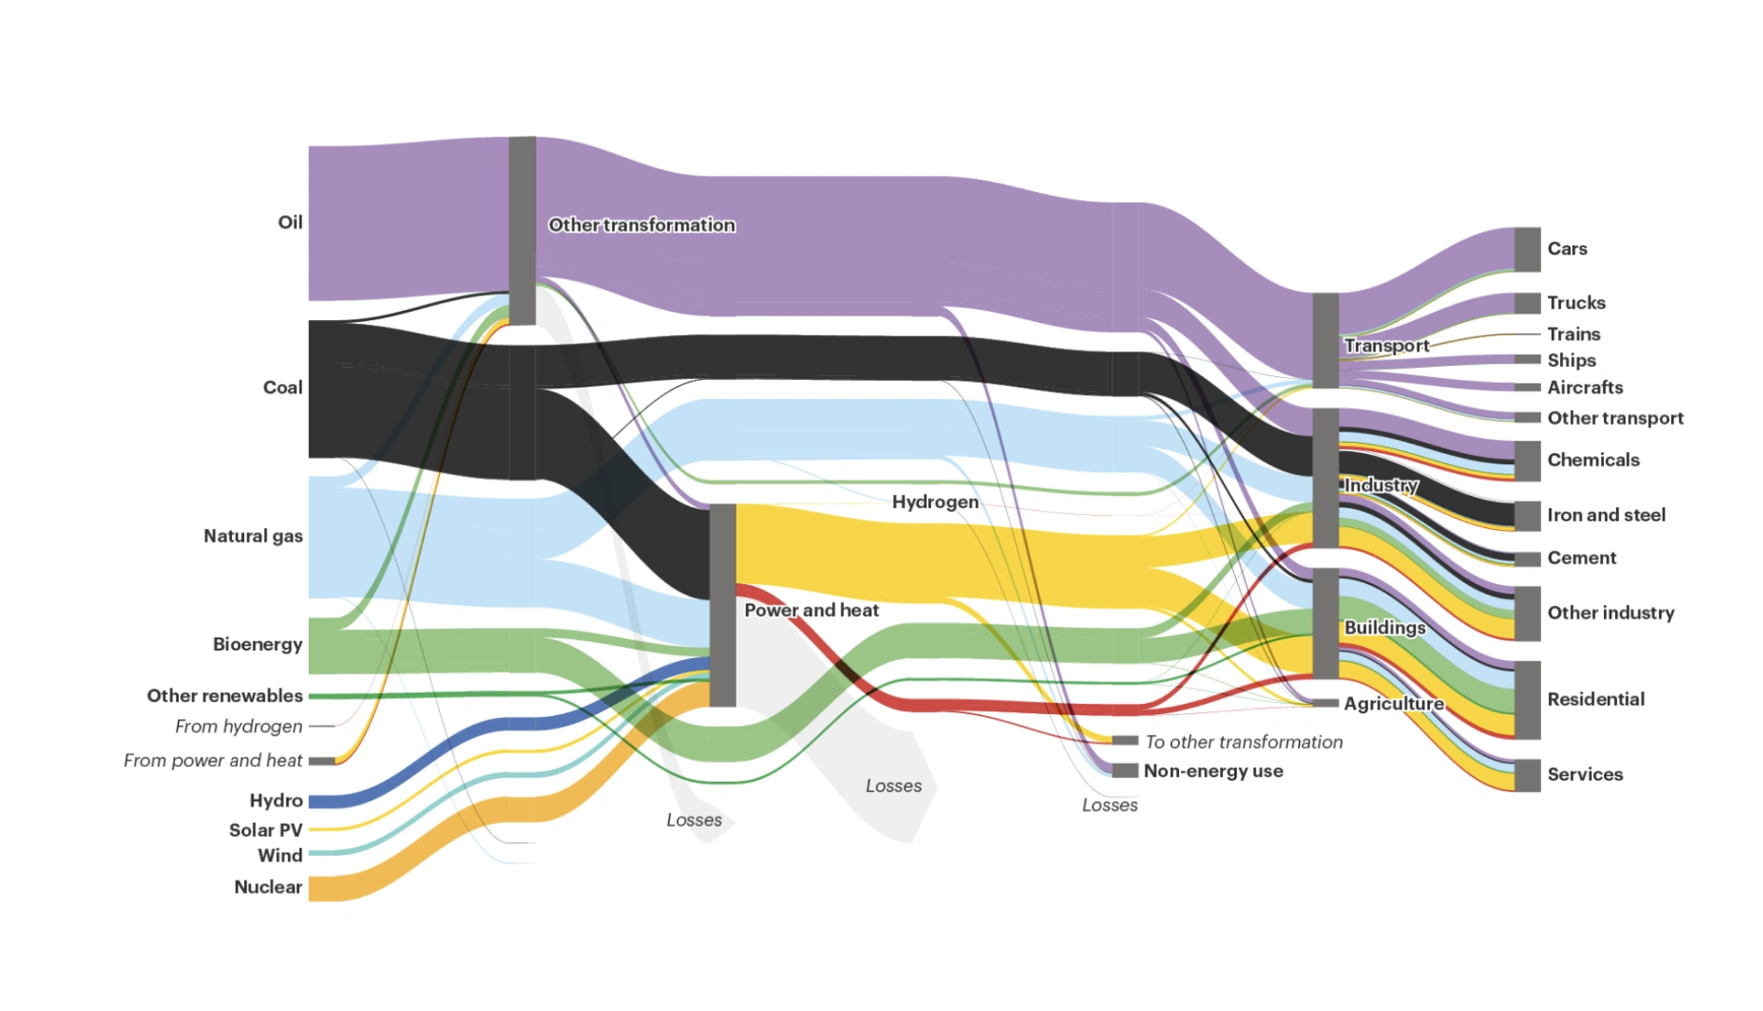
Global Energy Flows in the NZE Scenario (2021)
Where We Need to Go: Building a Just and Climate-Aligned Energy System
To reach universal energy access and climate goals, we need to completely reimagine how energy is produced, distributed, and used.
The energy system we need is:
Renewable
Powered by solar, wind, hydro, and green fuels—aligned with a 1.5°C future.
Clean
A system that does not create harmful pollution and greenhouse gases.
Inclusive
Designed to serve the energy-poor, empower women, and create livelihoods.
Cross-sectoral
Delivering integrated development gains, from health and food security to education and climate resilience.
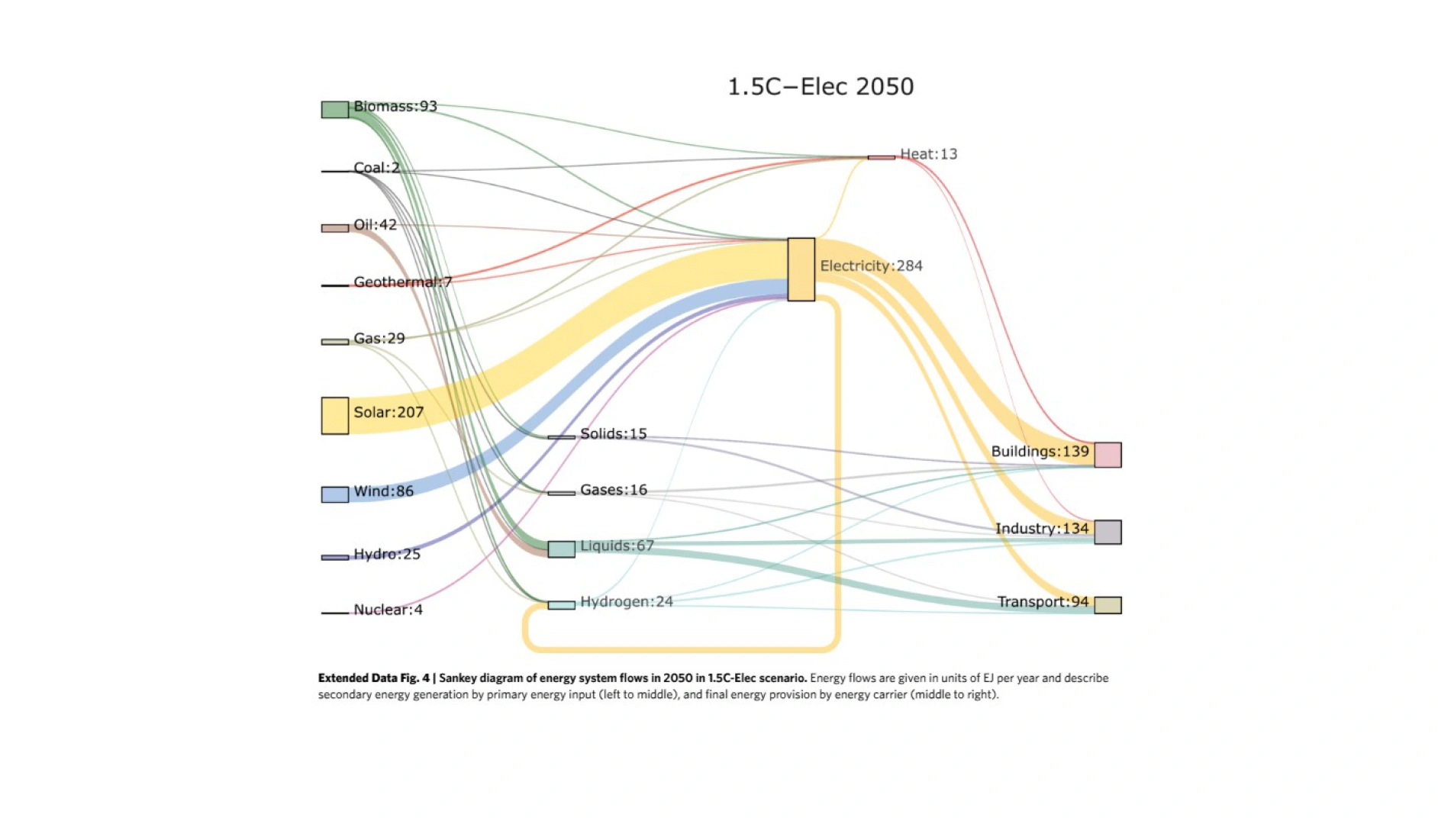
The Energy System We Need: Energy Flow in 2050 in a 1.5° Aligned Scenario
How Do We Get There
The next decade is decisive. Infrastructure decisions made today will shape the lives of generations to come. So what must we do?
Position decentralized renewables as core development infrastructure, not just a climate solution.
Scale up digital, data, and AI to improve access, efficiency, and equity in energy systems.
Close the finance gap by building pipelines of bankable projects that deliver multiple benefits from powering rural clinics and schools to preserving biodiversity and boosting food systems.
Align public policy, regulation, and private capital toward inclusive, climate-compatible energy futures.
As we have learned in this lesson, a just energy transition is not just a technical challenge. It’s a question of power, values, and urgency. The energy transition will not succeed unless it works for everyone, especially those historically left behind.
In the rest of the module, we’ll dive deeper into how we got here, what needs to change, and we can lead the charge toward a just, inclusive, and sustainable energy future.
Achieving universal energy access and net zero emissions by 2050 will require nothing short of the complete transformation of the global energy system.
Which paradox best illustrates the challenge of balancing economic growth and environmental sustainability in energy development?
- High energy consumption driving economic progress despite environmental impacts
- Adopting renewable energy that requires extensive resource use and land
- Energy efficiency measures that might lead to increased overall consumption
- Switching to clean energy sources that depend on finite materials
Key Takeaways
Energy is essential for development, but the way we produce and use it threatens that very goal. Reliable, affordable energy powers everything from healthcare and education to jobs and economic growth. Yet the global energy system—still overwhelmingly fossil-fueled—is the primary driver of climate change. This twin imperative is the defining challenge of our time, especially for low-income and climate-vulnerable countries.
Despite progress, our current system is includes paradoxes that hold us back. Clean energy investment is growing fast. But fossil fuels still dominate global energy supply, and the communities most in need receive the smallest share of investment. These contradictions reflect not just technical gaps but deep political and financial imbalances.
A just energy future is possible but it demands bold, systemic change. To build an energy system that delivers for both people and planet, we need to shift toward renewable, inclusive infrastructure supported by digital innovation and fair financing.
Key Resources
Energy and Development in a Changing World: A Framework for the 21st Century
Energy Development as a Driver of Economic Growth
Energy-Based Economic Development

Lesson 1.1.2: Lesson 2: The Complexities of Global Energy Use
Lesson
The Complexities of Global Energy Use
M1: Introduction to Sustainable Energy System Transformation
Lesson 2 Overview
Energy powers our world—from homes and hospitals to industries and digital systems. It is the backbone of modern life, essential for delivering critical social services such as healthcare, education, water supply, heating, and cooling. But energy is not just about convenience—it shapes living standards, economic opportunity, public safety, and resilience.
Yet energy access, the ability to obtain a basic level of electricity and clean cooking 💬️ solutions, is not enough. Energy must be reliable, affordable, and adequate in order to realize full gains.
To unlock human potential and drive sustainable development, we need energy systems that are not only available—but reliable, inclusive, and resilient—systems that uphold basic rights, enable access to clean water and sanitation, and strengthen community safety and well-being.
Key Concepts
Explore foundational ideas from this lesson.
nationally determined contributions
Nationally Determined Contributions (NDCs) are the climate action plans that countries submit to outline their commitments to reduce greenhouse gas emissions and adapt to climate change, as part of the Paris Agreement.
sustainable energy & renewable energy
Sustainable energy refers to energy sources that are environmentally friendly and can be maintained over the long term without depleting resources or harming the ecosystem. Renewable energy is a subset of sustainable energy that comes from natural processes that are continuously replenished, such as solar, wind, and hydro power.
just energy transition
A just energy transition refers to the shift from fossil fuels to renewable energy sources in a way that is fair and equitable, ensuring that all communities, especially those historically marginalized, benefit from the transition and are not left behind.
As we have seen previously, energy plays a crucial role in achieving prosperity, and as societies grow and thrive, their dependence on energy and the services it provides increases significantly. However, this pursuit of economic growth, especially through increased fossil fuel consumption, often comes at a cost to the environment.
The energy trilemma—balancing energy security, equity, and sustainability—captures these complex trade-offs between energy production, economic advancement, and state of environment.
It reflects the challenge of ensuring a reliable and resilient energy supply (security), providing universal access to affordable energy (equity), and reducing environmental and climate impacts (sustainability). As countries seek to expand access and meet rising demand, they must navigate difficult trade-offs between driving economic development, safeguarding ecosystems, and protecting communities from the risks of both energy poverty and climate change.
This trilemma is not just an abstract concept; it is deeply intertwined with issues of fairness and equity. Developing countries and regions reliant on fossil fuels often face a difficult balancing act: ensuring reliable energy access (security), maintaining affordable prices (equity), and advancing environmental protection (sustainability).
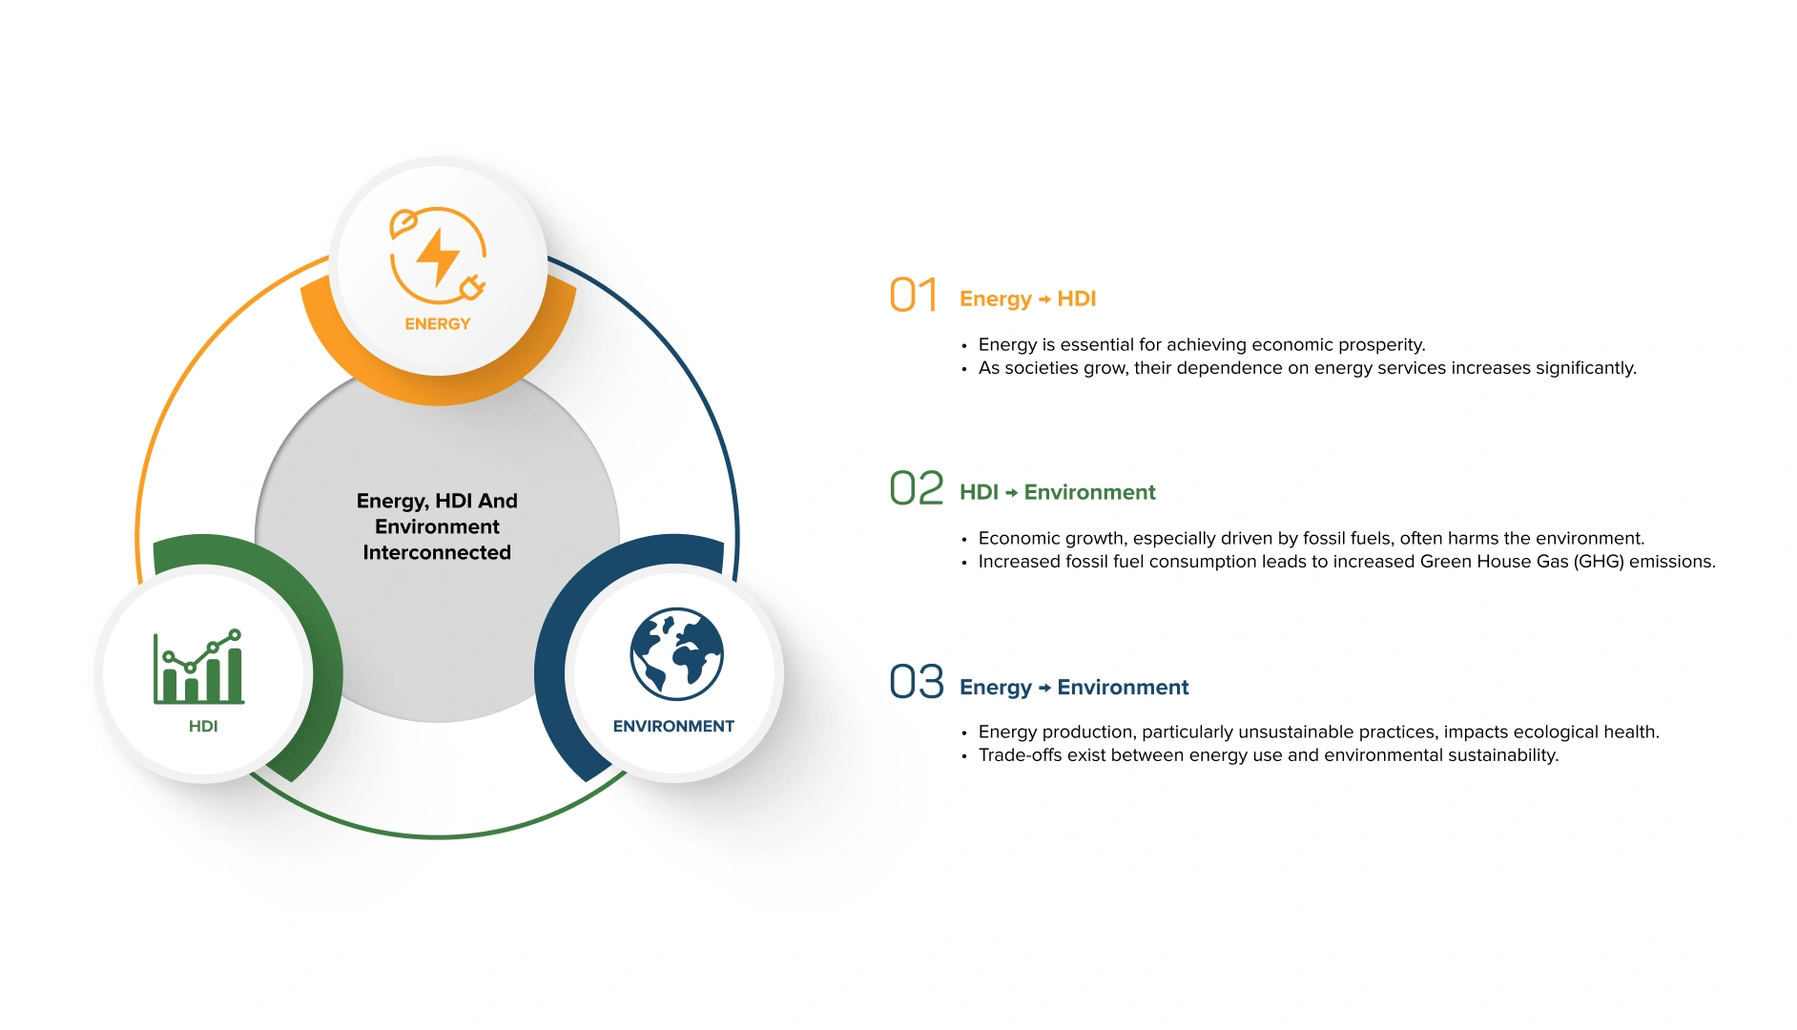
Energy, HDI, and Environment Interconnected
M1: Introduction to Sustainable Energy System Transformation
A: Energy Consumption Disparities
Significant disparities exist globally in energy use, prosperity, health, political influence, and resource demands.
Global energy use remains deeply unequal—reflecting broader disparities in wealth, health, political influence, and resource consumption.
Per capita energy consumption underscores the scale of this divide. An average American, for example, uses 12 times more energy than an average Indian—consuming in one month what an Indian uses in an entire year (Our World in Data, 2023). The gap is even wider between North America and Africa, where the average North American consumes over 50 times more energy than the average African. Even among middle-income countries, stark contrasts remain.
These disparities highlight not only differences in income and infrastructure—but also unequal access to the many benefits energy enables, from healthcare and education to mobility, productivity, and climate resilience.
The graph below compares per capita energy use across regions, highlighting the stark inequalities in global energy consumption.
The previous graph highlights the significant disparity in annual energy use per person across regions. This doesn’t only include electricity, but also all energy use, including gasoline for cars and home heating. The data were converted into kilowatt-hour (kWh) per person per year, using the “substitution method” that calculates how much energy input would be needed to generate the same amount of electricity if it were from fossil fuels.
To put the figures into perspective, we can look at the consumption of a few household appliances:
One person in the United States with an average energy usage of 77,000 kWh/year. That’s enough to:
Run a central A/C system (3 kWh/hr) 24/7 all year long,
AND power a 10.5 kWh/hour electric furnace for 4 hours a day during winter,
AND use a dishwasher daily, a fridge, a microwave, coffee maker, and multiple TVs and computers,
AND still have enough left over to charge an electric car regularly and take multiple long-haul flights.
One person in China uses 33,000 kWh/year. That’s enough to:
Run a window A/C unit (0.73 kWh/hr) for 10 hours/day,
Power a heat pump water heater, fridge, lighting, and kitchen appliances,
But still use less than half the energy of someone in the U.S.
One person in Bangladesh uses about 3,000 kWh/year. This energy level can support:
Continuous use of a modern energy-efficient refrigerator (~350–500 kWh/year),
Basic lighting and several fans (pedestal or ceiling) for daily comfort,
Occasional use of kitchen appliances like a microwave, toaster, or electric rice cooker,
Limited use of energy-intensive appliances like A/C or water heaters—these would need to be used selectively or seasonally.
It is important to note that energy use may also vary widely within countries, millions in high-income countries still face energy povertya concept further explored in the next modulewhile a growing middle class in low- and middle-income countries are rapidly increasing their energy use.
National averages hide significant inequality within borders.
M1: Introduction to Sustainable Energy System Transformation
B: Energy Use and Climate Change
The way we produce and consume energy remains the single largest contributor to climate change, with fossil fuels at the core of the issue.
From 1990 to 2022, global carbon dioxide (CO₂) emissions from energy use have risen sharply, growing from approximately 21.5 gigatonnes (Gt) to around 36.8 Gt, an increase of over 70% in just three decades (IEA, 2022). This rise is primarily driven by the expansion of fossil fuel-based energy systems to power industrial development, economic growth, urbanization, and rising living standards across both developed and emerging economies.
A key factor behind this surge has been the dominance of coal, oil, and natural gas, which still account for over 80% of global energy consumption (S&P Global, 2022). Fossil fuels have remained an important part of electricity generation, transportation, and industrial activity. At the same time, while renewable energy has grown significantly since the early 2000s, it has not yet displaced fossil fuels at the global level. In fact, energy demand continues to climb due to increasing consumption from population growth, digital infrastructure, and industrial expansion, especially in Asia and parts of Africa.
The following graph illustrates this trend, showing the rise in global energy-related CO₂ emissions. The data underscores a sobering reality: while energy is essential for development, our current systems are locked into carbon-intensive pathways that endanger planetary stability unless urgently reformed.
Reaching net zero emissions targets requires both an energy transition and approaches that “leapfrog” historic energy development pathways.
However, it is important to note that the history of energy has been more a history of energy additions than energy transitions.
Energy sources, like coal, oil, and now renewables, tend to layer on top of existing ones rather than fully displacing them. For example, while the share of coal in the global energy mix has declined in relative terms, absolute coal consumption is higher today than it was in 1990, as energy demand continues to grow globally.
This additive dynamic reflects both the inertia of incumbent systems and the surge in demand from industrialization, urbanization, and population growth. The result is that renewables are expanding rapidly, but so is fossil fuel use, as demonstrated in the following graph.
Understanding this complexity is essential to designing energy strategies that don't just add green capacity, but actively phase out the most polluting fuels.
M1: Introduction to Sustainable Energy System Transformation
C: Inefficiencies in the Global Energy System
The current global energy system operates at only 37% efficiency (RMI, 2019), meaning that nearly two-thirds of the primary energy produced is lost due to inefficiencies in generation, transportation, and end-use.
As seen in the following graph, in 2019, about 33% of the energy produced globally was lost before even reaching consumers, due to production and transportation inefficiencies (RMI, 2024). Another 30% was wasted on the demand side, as energy was converted into useful energy.
More specifically, most energy losses come from inefficiencies in fossil fuel production and delivery (177 EJ/year), transportation (19 EJ/year), and usage (183 EJ/year). Fossil fuel power plants and internal combustion engines account for nearly half of global energy waste, alongside significant losses from the underutilization of byproducts and waste heat.
Wasting 379 EJ of energy each year results in a loss of approximately $4.6 trillion globally—$1 trillion on the supply side and $3.6 trillion on the demand side.
This equates to 40% of global energy spending and 5% of global GDP, which is roughly double the annual investments in the energy system.
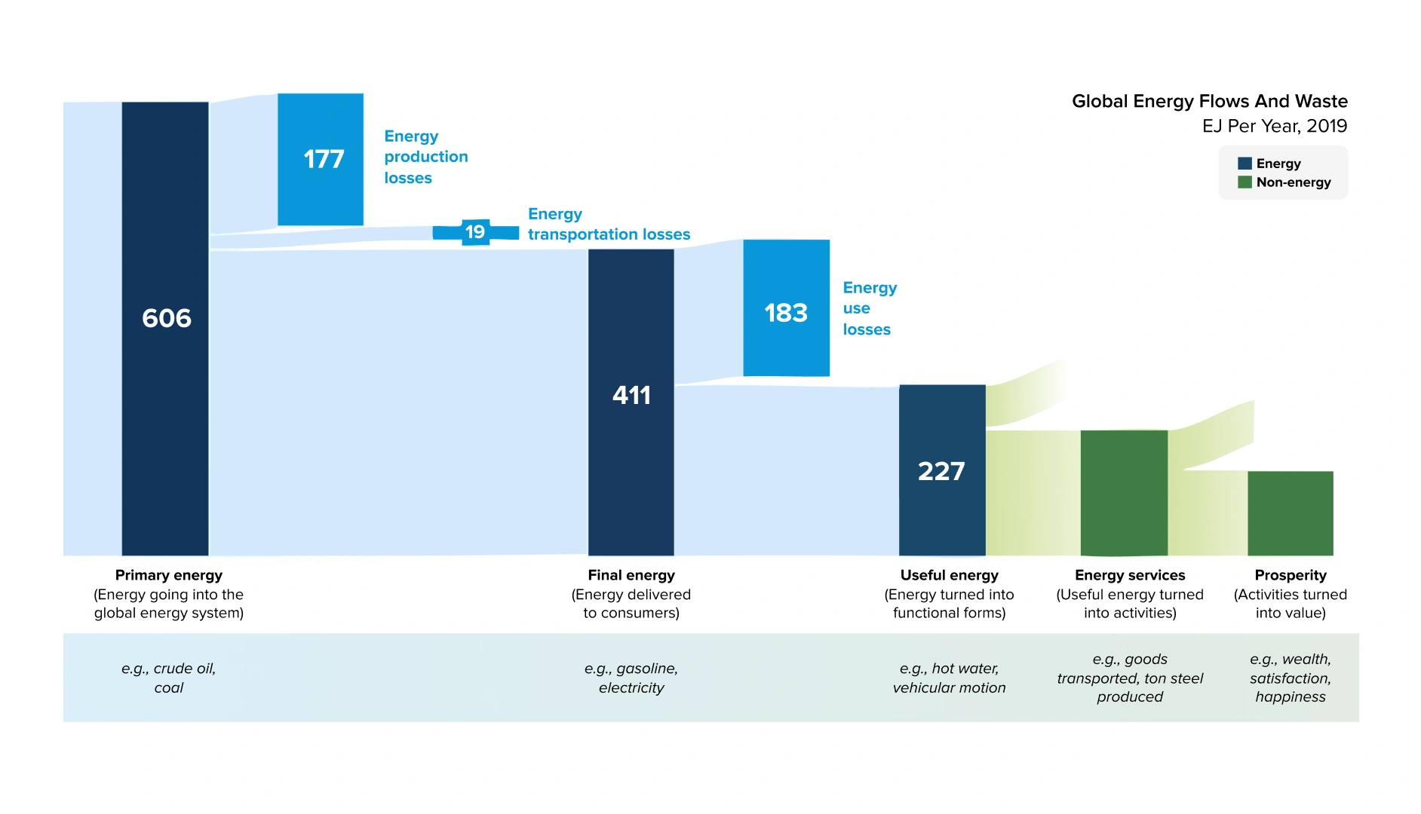
Energy System Losses from Primary to Useful (2019)
M1: Introduction to Sustainable Energy System Transformation
D: Balancing Energy Security with Fossil Dependency and Global Demand Growth
Fossil Fuel Dependency:
A Fragile Foundation for Energy Security
Relying on fossil fuels for energy security presents a paradox. While fossil fuels currently account for around 82% of global energy consumption (IEA, 2021), the real challenges lie in the geopolitical, economic, and environmental vulnerabilities they create.
Many major fossil fuel-exporting countries may present some aspects of political instability. Conflicts or governance disruptions in countries like Libya, Venezuela, or Nigeria have repeatedly disrupted the global supply of oil and gas. For low-income, energy-importing countries, such shocks can trigger severe energy shortages, rising fuel costs, and disruptions in essential services like electricity, healthcare, and transportation. In Sub-Saharan Africa, most countries are net importers of fossil fuels , leaving them highly exposed to global price swings.
Fossil fuel systems also rely on complex and fragile infrastructure—pipelines, ports, shipping lanes, and refineries—that are vulnerable to accidents, cyberattacks, climate impacts, and geopolitical tension. For example, the closure of the Suez Canal for six days in 2021 delayed roughly 9.6 billion USD in trade daily (BBC, 2021), including critical oil shipments.
Even for fossil fuel producers, energy security is not guaranteed. Countries with abundant fossil resources may still suffer from the “resource curse”—a pattern where energy wealth fuels corruption, conflict, or inequality rather than inclusive development. Fossil fuel exports can provide short-term economic benefits, but they also expose nations to price volatility. For instance, the price of oil dropped from over $110 per barrel in 2014 to below $30 in 2016, destabilizing budgets in oil-dependent economies like Angola and Iraq (World Bank, 2018).
Moreover, fossil fuel dependency often leads to unequal access to energy benefits. Wealth generated from extraction does not automatically reach all citizens, and fossil fuel infrastructure tends to be centralized, bypassing remote or marginalized communities 💬️. As a result, fossil fuels can entrench inequality while failing to deliver secure, affordable energy for all.
In short, fossil fuel dependency poses systemic risks to energy security because they tie countries to a volatile and unsustainable global system. Building resilience requires rethinking energy systems around diversification, decentralization, and sustainability.
Rising Demand: A Growing Pressure on Energy Systems
Key Takeaways
Energy is essential for economic growth and human well-being, yet disparities in energy access and use highlight stark inequalities in prosperity, access to social services, and resource availability across nations, particularly in developing economies.
The energy-prosperity-environment trilemma underscores the need to balance economic development with environmental protection, especially in regions heavily reliant on fossil fuels. Sustainable energy strategies are vital to achieving this balance without compromising progress.
With fossil fuels dominating the inefficient energy system and driving climate change, a transition to renewables and improved energy efficiency is critical. As global energy demand rises, this transformation will be key to ensuring security, equity, and sustainability.
Key Resources
World Energy Outlook 2024
Global Energy Perspective 2024
World Energy Transitions Outlook 2024

Lesson 1.1.3: Lesson 3: The Sustainable Energy Landscape
Lesson
Sustainable Energy Landscape
M1: Introduction to Sustainable Energy System Transformation
Lesson 3 Overview
Considering the energy system outlined in the previous section prompts an important question:
How can humanity provide equitable access to energy benefits for a growing global population without degrading the environment or exhausting irreplaceable resources?
This is where ‘sustainable energy’ comes into play.
Sustainable energy is derived from resources and systems that meet the needs of the present without compromising the ability of future generations to meet their own needs.
Among the most popular sources of sustainable energy are wind, solar, and hydropower, all of which are renewable. The goal of sustainable energy is to navigate the trade-offs involved and develop effective technological and policy solutions that lead to environmentally sound and consumer-friendly energy futures.
Sustainable energy plays a critical role in transitioning to a new energy model that tackles three major global challenges: protecting the environment, ensuring energy security, and promoting socio-economic development.
It is important to note that while sustainable energy and renewable energy are closely related, sustainable energy also emphasizes efficiency and affordability. Renewable energy refers to energy sources that come from resources that are replenishable, such as wind or solar power. Sustainable energy, however, goes further, addressing efficiency, responsibility to future generations, and universal access to energy. Combining these concepts—renewable and sustainable energy—can help us create an energy model that is both forward-thinking and fair.
M1: Introduction to Sustainable Energy System Transformation
A: Sustainable Energy as an Enabler of Development
Transitioning to sustainable energy delivers transformative benefits across key areas:
Enhanced Energy Security
Roughly 80% of the global population—around 6 billion people—depend on imported fossil fuels, leaving them exposed to price volatility and geopolitical risks. Renewables, accessible in all countries, could meet 90% of global electricity needs by 2050, potentially enabling nations to reduce dependency and stabilize their economies.
Greater Affordability
Some renewable energy products and technologies have become the cheapest energy source in many parts of the world. Between 2010 and 2020, solar power costs plummeted by 85%, while onshore and offshore wind saw reductions of 56% and 48%. These falling costs make renewables a viable solution for growing energy demand, especially in low- and middle-income countries, while also tackling energy poverty, which affects 1.18 billion people worldwide. (UNDP, 2024)
Improved Public Health
Fossil fuels, largely responsible for air pollution, are linked to 13 million preventable deaths each year and $2.9 trillion in 2018 in health-related economic losses (CREA, 2020). Clean energy sources like wind and solar significantly reduce air pollution, addressing both environmental and public health challenges.
Job Creation
Clean energy jobs are expanding rapidly, with employment in the sector growing more than 3.6 times faster than fossil fuel jobs globally in 2023. By 2030, the clean energy sector could add 14 million new jobs globally, with another 16 million in industries like electric vehicle manufacturing—bringing total employment in the transition to over 30 million (IEA, 2021).
These are just a few of the opportunities offered by sustainable energy, with more benefits explored throughout the module.
M1: Introduction to Sustainable Energy System Transformation
B: SDG7: Affordable and Clean Energy
The world has made significant strides toward sustainable energy targets. Since 2015, the number of people without electricity has dropped from 958 million to 666 million, and those without access to clean cooking 💬️ fuels fell from 2.8 billion to 2.1 billion (IEA, 2025). Renewable energy capacity is expanding rapidly, with growth expected to continue at an unprecedented pace.
Yet, progress remains uneven and too slow to meet global targets. By 2030, 660 million people are still projected to lack electricity, and 1.9 billion could remain without access to clean cooking solutions if current trends persist (UNSDG, 2023). These challenges highlight the urgent need for action, especially as energy systems face growing pressure to align with the Paris Agreement.
M1: Introduction to Sustainable Energy System Transformation
C: Progress and Ambition of the Energy Transitions
* COP28, or the 28th Conference of the Parties, was the 2023 United Nations Climate Change Conference.
At COP28, the UAE Consensus reaffirmed global commitments to accelerate the energy transition, including tripling global renewable energy capacity and doubling energy efficiency 💬️ by 2030. The agreement also marked the first explicit call for transitioning away from fossil fuels, underscoring the urgency of shifting to cleaner energy systems.
Meeting the global target of tripling renewable capacity by 2030, reinforced at COP28*, will require an additional 5,500 GW of capacity to be constructed by the end of the decade, according to the IEA.
Electricity is driving the global shift to renewables, while progress in heating and transport remains slower. The share of renewables in total final energy consumption increased from 16.7% in 2015 to 18.7% in 2021 (IEA, 2024).
The electricity sector has seen major gains, driven by falling costs for wind and solar power. By 2021, renewables made up 28.2% of electricity consumption, rising from 22.9% in 2015.
Global gains in renewable energy have been impressive, with per capita installed capacity for renewable electricity nearly doubling from 248 watts in 2015 to 478 watts in 2023 (IEA, 2025). Over the past five years, the sector achieved an unprecedented annual growth rate of 9.4%.
But this progress is not shared equally. In 2022, Least Developed Countries (LDCs) reached just 40 watts per capita, while Landlocked Developing Countries (LLDCs) and small island developing states 💬️ (SIDS) achieved 105 and 110 watts, respectively. This stark disparity highlights the urgent need to accelerate efforts and ensure equitable access to sustainable energy worldwide.
This disparity stems from limited investment, high capital costs, weaker grid infrastructure, and challenges in accessing finance—all of which hinder renewable energy deployment in many developing economies.
More on how to overcome these challenges in the upcoming modules.
Despite commitments through nationally determined contributions 💬️ (NDCs) and Long-Term Low Emission Development Strategies (LT-LEDS), the current efforts are not enough to meet the 1.5°C target.
If all pledges made in the run up to COP28 were fully implemented, CO2 emissions would drop by just 1.4 gigatonnes (GtCO2) by 2030 and 2.3 GtCO2 by 2050. This still leaves a gap of 18 GtCO2 to close by mid-century. At this rate, global energy-related emissions would reach 35.2 GtCO2 in 2030—far above the 23 GtCO2 required under the 1.5°C pathway outlined by the International Renewable Energy Agency (IRENA).
Current pledges could cut emissions by 3% by 2030 and 51% by 2050 compared to 2022 levels (UNDP, 2025). While this represents some progress, it falls well short of what is needed to keep global warming within safe limits.
However, this outlook may change, as countries are set to update their NDCs by COP30. The upcoming revisions could strengthen 2030 and 2050 targets, potentially closing some of the emissions gap.
Advancing a just energy transition 💬️
With the adverse impacts of climate change worsening each year, and the window for action rapidly closing, countries are strengthening efforts to decarbonize, green their economies, and build resilience. However, achieving the goals of the Paris Agreement, which is to limit global warming to 1.5 degrees Celsius or less, requires unprecedented change in how we do things. Yet, as history has shown, abrupt change can incur a hefty price on workers and society. As these shifts unfold, momentum is growing around the concept of a just transition, focused on both workforce impacts and broader environmental and social justice concerns.
A just transition means greening the economy in a way that is as fair and inclusive as possible to everyone concerned, creating decent work opportunities and leaving no one behind. A just transition involves maximizing the social and economic opportunities of climate action, while minimizing and carefully managing any challenges – including through effective social dialogue among all groups impacted, and respect for fundamental labour principles and rights. (ILO)
The concept of a just energy transition ensures that the shift to sustainable energy systems addresses inequalities and promotes inclusivity. It seeks to balance the urgent need to reduce carbon emissions with the responsibility of equitably distributing the benefits and burdens of this transition. Special attention is given to vulnerable and marginalized groups, such as low-income communities, Indigenous Peoples—whose land rights and traditional practices are often at stake—women, and workers in carbon-intensive industries, who might otherwise be disproportionately affected.
By embedding principles of fairness and equity, a just energy transition supports livelihoods, fosters social cohesion, and ensures that no one is left behind in the journey toward a sustainable future.
Promisingly, momentum around “just transition” is gathering pace. We are seeing it emerge in the global dialogue around decarbonization 💬️ and net zero. More countries are referencing it in their short and long-term climate plans. Partners are coming together, and coalitions are forming.
More on just energy transitions in Module 3.
Key Takeaways
Transitioning to sustainable energy brings transformative advantages, such as enhancing energy security by reducing dependence on fossil fuel imports, making energy more affordable through declining renewable costs, improving public health by reducing air pollution, and driving job creation.
The world has made notable strides toward sustainable energy, with renewable energy capacity growing rapidly and the number of people without electricity decreasing gradually. However, progress is uneven, with Least Developed Countries (LDCs), Landlocked Developing Countries (LLDCs), and Small Island Developing States (SIDS) lagging far behind, emphasizing the need for targeted efforts to bridge this gap.
Current efforts and pledges to reduce CO2 emissions are insufficient to achieve the 1.5°C target of the Paris Agreement. A significant gap remains, requiring accelerated policy implementation, technological innovation, and international collaboration to close the emissions gap and meet global climate goals.

Lesson 1.1.-1: Chapter 1 Outro

Chapter 1.2: Chapter 2: Interlinkages between Energy and Other SDGs

Lesson 1.2.0: Chapter 2 Introduction
Chapter
Interlinkages between Energy and Other SDGs
M1: Introduction to Sustainable Energy System Transformation
Chapter 2 Overview
Since the 2030 Agenda for Sustainable Development was conceived to be integrated and indivisible, the SDGs are interlinked and interdependent by design. SDG Interlinkages refer to the complex network of interconnections among goals, targets and indicators.
Actions toward one SDG can have positive or negative impacts on others, varying across geographical and temporal scales. Understanding this complexity and the directionality of change is key for achieving the Agenda goals while safeguarding against negative feedback loops/externalities. Such an approach facilitates the creation of integrated solutions that drive simultaneous progress across multiple SDGs by maximizing synergies and minimizing trade-offs, which aids in optimizing resources and accelerating response times.
However, solutions are not one-size-fits-all; they demand tailored approaches aligned with national priorities. This chapter aims to empower participants as change-makers and leaders in innovative sustainable development solutions, fostering multiple SDG achievements within energy initiatives. The lessons elucidate the complex relationship between electricity access and clean cooking (SDG 7.1), renewable energy (SDG 7.2) and energy efficiency 💬️ (SDG 7.3) and other SDGs.
Lesson 1: Access to electricity and clean cooking (SDG 7.1)
Catalyzing progress across the SDGs through universal energy access
Lesson 2: Renewable energy (SDG 7.2)
Leveraging the SDG synergies and navigating the trade-offs in the energy transition
Lesson 3: Energy Efficiency (SDG 7.3)
Improving energy efficiency for building sustainable and resilient socieities

Lesson 1.2.1: Lesson 1: Access to electricity and clean cooking (SDG 7.1)
Lesson
Access to Electricity and Clean Cooking (SDG 7.1)
M1: Introduction to Sustainable Energy System Transformation
Lesson 1 Overview
The goal of ensuring universal access to affordable, reliable, and modern energy services, such as electricity and clean cooking 💬️ services, appliances and fuels, is framed within SDG 7.1. Its interconnectedness with various goals offers synergies to address multiple global challenges simultaneously, amplifying opportunities for poverty reduction, gender equality, education, health, food security and economic development.
Key Concepts
Explore foundational ideas from this lesson.
clean cooking
Clean cooking refers to the use of safe, efficient, and environmentally friendly cooking technologies and fuels that reduce indoor air pollution and minimize health risks, while also lowering greenhouse gas emissions.
energy and health
The relationship between energy consumption, production, and its impact on human health, including how energy systems affect air quality, access to clean water, and overall well-being.
sdg synergies
SDG synergies refer to the interconnected benefits and positive interactions that occur when efforts to achieve one Sustainable Development Goal (SDG) also support the achievement of other SDGs, leading to more effective and holistic progress in sustainable development.
SDG Target 7.1
By 2030, ensure universal access to affordable, reliable and modern energy services
Indicators
7.1.1
Proportion of population with access to electricity
7.1.2
Proportion of population with primary reliance on clean fuels and technology
M1: Introduction to Sustainable Energy System Transformation
A: Enlightening Education
Well-lit, heated, and cooled schools, work spaces and households create comfortable, safe and effective learning spaces for children and adults (SDG 4).
Access to affordable, reliable, and modern energy in schools significantly improves education quality and accessibility. Electricity access in educational setups extends education opportunities into evening classes, catering to diverse schedules. Modern information and communication technologies (SDG 9), powered through electricity access, significantly enhance learning experiences and foster digital literacy 💬️. Furthermore, access to the Internet supports digital connectivity of rural schools, which during COVID-19 has been key for educational resilience.
In addition, electricity facilitates the provision of Water, Sanitation, and Hygiene (WASH) services, which are particularly important for girls and adolescent girls, as access to these services is linked to lower dropout rates. Consequently, access to quality education results in enhanced educational attainment and high completion rates, providing lifelong benefits to children.
M1: Introduction to Sustainable Energy System Transformation
B: Enhancing Health Services and Water Access
Access to reliable electricity is fundamental for health services (SDG 3), including safe childbirth, vaccinations, diagnostics, and emergency response.
Nearly 1 billion people in low- and lower-middle-income countries lack reliable electricity in healthcare facilities (WHO, 2023). Electricity enables rural populations to store and refrigerate medicines and vaccines, ensuring community health. It powers lighting, communication, and vital medical devices, such as ventilators and dialysis machines.
Furthermore, the lack of reliable energy contributes to indoor air pollution, as many rely on biomass or kerosene for cooking and lighting, leading to respiratory and cardiovascular diseases, particularly affecting women and children. Electricity is also key for improving household health conditions, through clean indoor environments, cooking facilities, and thermal comfort (heating and cooling 💬️). Energy also contributes to expanding water and sanitation services (SDG 6), particularly in water-stressed regions.
Energy also contributes to expanding water and sanitation services (SDG 6), particularly in water-stressed regions. Decentralized solar PV water pumps can replace more expensive diesel pumps, and mini-grids can power filtration technologies, such as reverse osmosis systems, to produce clean drinking water (IEA, 2023), powering a shift toward unconventional water supply options (e.g., desalination). Electricity is essential in health facilities, powering medical devices, refrigeration for vaccines, and providing access to clean water and sanitation, which are vital for public health.
M1: Introduction to Sustainable Energy System Transformation
C: Improving Food Security and Productive Development
Providing affordable, reliable, and modern energy services to the world's poor aligns with poverty eradication and reducing inequalities (SDG 1 and SDG 10).
In rural areas, where many lack energy access, empowering smallholder farmers with energy facilitates groundwater pumping, mechanization of farming, and maintenance of temperature-controlled supply chains. This enhances food crop yields, diversifies regional diets, contributes to income generation (SDG 2 and SDG 8) and strengthens food security.
The World Bank Group projects that by 2030, two-thirds of the world’s extreme poor will live in fragile, conflict and violence settings. As a result, achieving SDG 2 (Zero Hunger) and SDG 10 (Reduce Inequalities) demands innovative and integrated solutions. The adoption of solar-powered irrigation systems in Yemen is an example of an innovative and conflict-resilient practice that has safeguarded food production capacities (Al-Eryani, 2022). Box 2 below briefly describes the World Bank Group's solar project in Yemen.
Between 2018 and 2022, the Yemen Emergency Electricity Access Project (YEEAP) spearheaded the expansion of electricity access in rural and peri-urban areas through solar solutions. This World Bank-funded initiative, executed by the United Nations Office for Project Services (UNOPS) alongside local entities, empowered six microfinance institutions to introduce financing products for small-scale energy systems. Over 3.2 million people, notably 51% female, accessed critical services like water, education, and healthcare, including support for COVID-19, through solar-powered facilities (source: World Bank Group).
M1: Introduction to Sustainable Energy System Transformation
D: Energizing Gender Equality
Indoor air pollution is estimated to cause around 13 deaths per minute, mostly affecting women and girls who shoulder household responsibilities and face exposure to polluting methods of lighting and cooking (SDG 3 and SDG 5). In some regions, women and girls are believed to spend up to 18 hours weekly on wood gathering and household cooking (UNDP, 2022). Therefore, access to clean energy directly aids in reducing women's time poverty 💬️. For instance, equipment such as fridges and washing machines can help achieve better educational attendance.
Access to energy fundamentally equates to access to opportunity. Yet, unless progress accelerates, by 2030 an estimated 341 million women and girls will still lack electricity. Studies indicate a 9 to 23% increase in women's employment post-electrification (UN, 2022). Public outdoor lighting increases security for women and girls, allowing more autonomy after dark and reducing exposure to gender-based violence. Similarly, information technologies and the Internet can help reduce the digital divide and foster digital inclusion for women and girls (WEF, 2023; ITU, 2020). Empowered women are more likely to drive local initiatives benefiting from cleaner cooking and lighting, which directly impacts their lives and families.
UNDP’s integrated projects in India and Nepal have shown promising results toward energy access, women’s equality and productive opportunities development (Box 3). UN Women's efforts in Ethiopia, included interest-free loans and entrepreneurship training benefiting over 19,500 women, enabling them to invest in an energy-saving cooking stove cooperative (Box 4).
It is essential to recognize that women are not just beneficiaries of sustainable energy solutions, but are critical actors and leaders in the energy transition. Women comprise 40% of the solar PV workforce, nearly double their participation in the oil and gas sectors of only 22%. Similarly, the clean cooking sector offers unique opportunities, as women represent half of managers in both bioethanol and electricity-powered cooking. Supporting women through investments and inclusive policies is therefore crucial, acknowledging their exceptional resilience and determination in breaking barriers and overcoming gender biases.
UNDP's energy access projects have significantly bolstered livelihoods, particularly for women, increasing income potential by up to 2.5 times. In India's Jharkhand State, solar stations facilitated by the UNDP have empowered women-run micro-enterprises, enabling them to produce essential hygiene products while earning an income. Similarly, in Nepal's Solta Bazaar, a solar minigrid supported a health lab and an IT training center, providing crucial services and education, sparing women long journeys for medical care (source: UNDP Climate).
The UN Women-Joint Programme, initiated in Ethiopia in 2011, unites six un agencies 💬️ to bolster gender equality and women's empowerment. With a focus on all 11 regions, it aligns with Ethiopia's development frameworks, aiming to enhance women's income, education, and rights while promoting leadership. Supported by Sweden and Norway, the program includes interest-free loans and business skill development, creating a revolving fund for women's empowerment. Notably, the initiative has enabled women, to invest in an energy-saving cooking stove cooperative, fostering economic empowerment within their village and beyond (source: UN Women).
In efforts to expand access to electricity and clean cooking, which policy instrument is most suitable for encouraging adoption among vulnerable communities?
- Implementing targeted subsidies for low-income households
- Mandating renewable energy standards for new buildings
- Organizing competitive auctions for off-grid solutions
- Requiring mandatory energy disclosures to consumers
Key Takeaways
Energy provides lighting, heating and cooling in schools and homes, enabling effective learning spaces Electricity access extends education into evening classes, fosters digital literacy, and supports Internet connectivity to rural schools.
Reliable electricity is fundamental for health services (SDG 3), including safe childbirth, vaccinations, diagnostics, and emergency response. Nearly 1 billion people in low- and lower-middle-income countries lack reliable electricity in healthcare facilities (WHO, 2023). Electricity powers lighting, communication, and vital medical devices, such as ventilators and dialysis machines.
Indoor air pollution is estimated to cause around 13 deaths per minute, mostly affecting women and girls who shoulder household responsibilities Additionally, in some regions, women and girls are believed to spend up to 18 hours weekly on wood gathering and household cooking (UNDP, 2022). Therefore, access to clean energy directly aids in reducing women's time poverty.
Key Resources
2024 Tracking SDG7 Report
SDG7 Interactions
A Vision for Clean Cooking Access for All

Lesson 1.2.2: Lesson 2: Renewable energy (SDG 7.2)
Lesson
Renewable Energy (SDG 7.2)
M1: Introduction to Sustainable Energy System Transformation
Lesson 2 Overview
Increasing renewable energy adoption aligns with SDG 7.2 and interconnects with multiple goals, offering solutions to various global challenges while providing opportunities for health, jobs, economic development, and gender equality. The UAE Consensus, established at COP28, reinforces this commitment by calling for the tripling of renewable energy capacity and the doubling of energy efficiency 💬️ by 2030 to accelerate the global energy transition. However, renewable energy initiatives should place particular attention to trade-offs such as water stress, land use conflicts, life cycle environmental impacts and governance issues, emphasizing community rights and sustainability.
Key Concepts
Explore foundational ideas from this lesson.
community rights in renewable energy
Community rights in renewable energy refer to the legal and social entitlements of local communities to participate in, benefit from, and have a say in renewable energy projects that affect their environment and livelihoods.
energy value chain
The energy value chain refers to the full range of processes involved in the production, distribution, and consumption of energy, including extraction, generation, transmission, and end-use.
water-energy-food nexus
The water-energy-food nexus refers to the interconnectedness of water, energy, and food systems, highlighting how the management of one resource affects the others, and emphasizing the need for integrated approaches to ensure sustainability and security in these critical areas.
SDG Target 7.2
By 2030, increase substantially the share of renewable energy in the global energy mix
Indicators
7.2.1
Renewable energy share in the total final energy consumption
This lesson explores renewable energy's complexities and includes case studies for a comprehensive understanding of its impacts.
M1: Introduction to Sustainable Energy System Transformation
A: Clean Energy for Water Management
Accelerating the deployment of renewable energy capacity is central to limiting greenhouse gas emissions and thus with the Paris Agreement's goal of limiting global warming to below 1.5°C (SDG 13).
Renewable energy sources are less water-intensive than conventional sources, which is highly relevant amid water scarcity and erratic flows caused by climate change. The global energy system used 10% of total global freshwater withdrawals in 2021, due to the essential role of water in the energy supply chain, from electricity generation to fossil fuel production (IEA, 2023). The IEA’s Net Zero Emissions by 2050 Scenario predicts a nearly 15% decline in water use within the power sector due to transitioning from coal to solar PV and wind energy.
Replacing off-shore petroleum extraction by renewable energy generated from offshore wind, wave and tidal power 💬️ farms can contribute to conserving and sustainably using marine resources (SDG 14). Upscaling of renewables will help decrease ocean acidification (via lower carbon emissions), accidental impacts from energy-production and transport activities on aquatic habitats, and marine thermal pollution from cooling at coastal power plants (ICSU, 2017).
M1: Introduction to Sustainable Energy System Transformation
B: Healthier Cities and Resilient Societies
According to the International Council for Science (2017), the use of renewable energy resources directly reduces air pollution.
Improving air quality, and by extension human health, is especially important for those living in the dense urban centers of rapidly developing countries (SDG 3). resilient infrastructure 💬️, inclusive industrialization, and innovation (SDG 9) are prerequisites for achieving the SDG 7.2 target. Clean energy systems, in particular, help create the conditions for cities and human settlements to be inclusive, safe, resilient, less-polluting, and more sustainable (SDG 11). An up-scaling of renewable energy can have a large impact on the sustainability of cities and communities.
Similarly, achieving SDG 7.2 is key to sustainable urban planning, transport, and housing, since renewable solutions are fundamental pillars of the solutions portfolio. Smart grids and energy communities facilitate the development of renewable energy at the domestic or neighborhood scale. Furthermore, decentralized renewable energy sources enhance resilience. This is exemplified by the City Energy Resilience Framework, developed by the Resilient Cities Network (R-Cities) and Urban Power (Box 8).
The City energy resilience 💬️ Framework (CERF) serves as a comprehensive guide for cities to bolster their energy transition and urban resilience. It encompasses aspects of electricity infrastructure, clean energy, equitable service access, emergency management, and recovery strategies. As an engagement tool, CERF unites stakeholders to evaluate challenges and opportunities for resilient energy systems based on local policies and initiatives. By highlighting global examples, CERF encourages dialogue on adopting multi-benefit energy solutions that empower urban communities to adapt and thrive amidst adversities (source: CERF).
M1: Introduction to Sustainable Energy System Transformation
C: Inclusive Working Opportunities
Renewable energy’s value chain presents new opportunities, particularly for women (SDG 5), as greater gender diversity has shown to enhance both effectiveness and financial performance. A just energy transition 💬️ is essential for equalizing opportunities in employment and leadership roles, emphasizing the importance of access to quality jobs and finance in empowering women and their families (UN Women).
Renewable energy deployment bolsters innovation and strengthens local, regional, and national employment objectives (SDG 8).
The global renewable energy sector employs 16.2 million people as of 2024, with significant growth in solar PV. Wind and hydropower, as well as liquid biofuels make up most of the rest of the growth in renewable energy jobs. China dominates employment in most renewable energy sectors, however Brazil has the most biofuel jobs (WEF, 2023). While gender parity remains low in the renewable energy sector and technical positions, it is argued that companies with at least 30% female leadership may yield higher profit margins and may be more inclined to invest in sustainability and environmental initiatives (SDGs, 2022).
Addressing gender gaps in science, technology, engineering, and mathematics (STEM) will help create a more inclusive talent pipeline, enabling more women to access quality jobs and leadership roles in the energy sector. UNDP-supported initiatives in Peru (Box 9) and Yemen (Box 10) showcase women's impact as clean energy promoters.
The e-Mujer, the Energy School for Women in Peru helps to close gaps in access to clean energy, contributes to advancing climate action, and reduces gender inequalities—a critical issue across the country. This pilot project, funded by the Global Environment Facility and implemented by the Peruvian Ministry of Energy and Mines and the UNDP, trained 290 rural women to use, install, maintain, and commercialize clean energy systems such as solar panels and improved cookstoves (source: UNDP).
In Yemen, rural women led the establishment of the nation's first private solar energy 💬️ grid under the Enhanced Rural Resilience in Yemen (ERRY) Joint Programme. Supported by the European Union (EU) and implemented by FAO, ILO, UNDP, and WFP across four Yemeni governorates, this initiative empowered ten female entrepreneurs through UNDP's 3x6 Approach. Over three years, the project aims to strengthen crisis-affected rural communities, focusing on sustainable livelihoods, food security, governance, social cohesion, and access to sustainable energy. UNDP collaborates with the Sustainable Development Foundation (SDF) in this endeavor.
Which metric would you track to evaluate the effectiveness of renewable energy deployment in achieving SDG 7.2?
- Percentage of renewable energy in the overall energy mix
- Number of households with access to clean energy sources
- Average cost of renewable energy technologies per unit
- Rate of reduction in fossil fuel reliance
Key Takeaways
Renewable energy sources are less water-intensive than oil and gas, especially relevant for water scarce regions The global energy system accounted for 10% of freshwater withdrawals in 2021. However, the IEA’s Net Zero Emissions by 2050 Scenario predicts a nearly 15% decline in water use within the power sector due to transitioning from coal to solar PV and wind energy.
Renewable energy directly reduces air pollution, improving health outcomes especially for those in dense urban centers Improving air quality, and by extension human health, is especially important for those living in the dense urban centers of rapidly developing countries (SDG 3).
Renewable energy systems can create jobs throughout the value chain - planning, installation, deployment, maintenance The global renewable energy sector employs 16.2 million people as of 2024, with significant growth in solar PV. Other growth sectors include wind, hydropower, and liquid biofuels
Key Resources
Addressing Energy’s Interlinkages with other SDGs
From goals to joules: A quantitative approach of interlinkages between energy and the Sustainable Development Goals
Building a Nature-positive Energy Transformation - Why a Low-Carbon Economy is Better for People and Nature

Lesson 1.2.3: Lesson 3: Energy Efficiency (SDG 7.3)
Lesson
Energy Efficiency (SDG 7.3)
M1: Introduction to Sustainable Energy System Transformation
Lesson 3 Overview
Framed within SDG 7.3, the global energy efficiency 💬️ target requires significant reductions in energy consumption, presenting both synergies and trade-offs on global and local scales. Energy efficiency presents synergistic opportunities of reducing planetary impacts and promoting sustainable societies. Yet, adopting these measures faces challenges, such as navigating the complexities of industrial degrowth and balancing economic and social impacts.
Key Concepts
Explore foundational ideas from this lesson.
energy and digitalization
Energy and digitalization refers to the integration of digital technologies into the energy sector, enhancing efficiency, management, and innovation in energy production, distribution, and consumption.
energy efficiency
Energy efficiency refers to using less energy to perform the same task or produce the same outcome, thereby reducing energy waste and lowering costs.
waste-to-energy solutions
Waste-to-energy solutions are processes that convert non-recyclable waste materials into usable forms of energy, typically electricity or heat, through methods such as combustion, gasification, or anaerobic digestion.
SDG Target 7.3
By 2030, double the global rate of improvement in energy efficiency.
Indicators
7.3.1
Energy intensity measured in terms of primary energy and GDP
M1: Introduction to Sustainable Energy System Transformation
A: Building Sustainable Societies through Energy Efficiency
Energy efficiency is key to reducing several adverse effects of the two previous SDG 7.1 and SDG 7.2.
On the one hand, energy efficiency measures can reduce the rebound effect of energy access. For instance, an integrated solution developed by the ICLEI organization enhanced to improve water and energy efficiency of health centers and maternity centers, addressing together several SDG such as 3, 5, 6 and 7 (Box 14), enhancing a more positive impact of energy access interventions. On the other hand, since energy efficiency reduces the amount of energy consumption, it has direct impacts on reducing energy-related environmental effects on climate (SDG 13).
The UAE Consensus reaffirms the global commitment to doubling the rate of energy efficiency improvements by 2030, recognizing it as a critical pillar for sustainable energy transitions and emissions reductions.
The Green Economic Development Project developed by the UNDP in Bosnia Herzegovina led to saving 700,000 USD annually, reducing emissions by 2.2 tons of CO2 annually and creating jobs for 664 people / month (SDG 8) (Box 15), contributing to sustainable cities, climate, education and energy goals. nature-based solutions 💬️ are gaining traction, counteracting heat waves and high temperatures in urban settings. By incorporating elements like blue infrastructure and green roofs, these approaches reduce per capita energy consumption and enhance urban microclimates (SDG 11) (WB, 2023).
The Green Economic Development Project developed by the UNDP from 2012 to 2022 has improved the energy efficiency of public buildings in Bosnia and Herzegovina for climate comfort. It has promoted fuel switch projects, automated energy consumption regulation and management of public-sector buildings, and implemented efficient public lighting. Education and capacity-building on energy management of public-sector buildings for end-users have also been provided (source: UNDP BiH).
M1: Introduction to Sustainable Energy System Transformation
B: Optimizing the Water-Food-Energy Nexus for Sustainability
The growing demand for water (SDG 6), food (SDG 2), and energy (SDG 7) exerts immense pressure on this interconnected nexus.
For instance, shifting dietary patterns towards water-intensive foods, coupled with an anticipated population surge to over 9 billion by 2050, could necessitate a staggering 50% increase in global food production. Integrated and efficient management of water, food, and energy presents synergistic opportunities to address these multiple challenges. Optimizing power plant operations, deploying advanced cooling systems, and embracing energy-efficient irrigation present viable solutions. Water services, acting as a cornerstone for demand-side energy management, offer opportunities for power generation and storage, with irrigation adjustments during low electricity demand periods and reduced pumping during peaks (IEA, 2023).
The intertwined nature of land, soil, and water systems calls for comprehensive efficiency measures across the agri-food chain. Precision irrigation guided by water providers' data and the safeguarding of ecosystems alongside agricultural and energy production are novel solutions to ensure environmental sustainability (UN Water, 2023). Efficient cold chain solutions are also key for supporting food security while reducing food waste (FAO, 2021).
M1: Introduction to Sustainable Energy System Transformation
C: Waste-to-energy Solutions
The UNDP's project in Sri Lanka, spanning 2019 to 2023, targets sustainable energy use in the Agro-Industry to cut emissions and boost savings. Focused on solar energy 💬️ and biogas, the project exemplifies a South-South cooperation led by China. It aims to build capacity, transfer technology, and apply biogas solutions, including converting slurry into organic fertilizer. By showcasing energy-efficient applications, waste management, and productivity gains, the project benefits from China's expertise, fostering capacity development in partner countries (source: UNDP).
M1: Introduction to Sustainable Energy System Transformation
D: Digitalization for Efficiency
Integrating digital solutions with energy infrastructure creates synergies, enabling increased efficiency and productivity (SDG 9, 11, 12).
Fourth Industrial Revolution technologies, like real-time analytics, significantly enhance energy efficiency and reduce waste across various channels (UNDP, 2018). Developing nations have immense potential to adopt Industry 4.0 in manufacturing, employing smart production tools like real-time analytics, automation, the Internet of Things (IoT) and Artificial Intelligences (AI) to enhance productivity and minimize environmental impact (UN, 2022). Agriculture 4.0, which leverages precision farming, autonomous machinery, AI-driven monitoring, and IoT-enabled smart irrigation, is also emerging for enhanced farming practices. Agricultural automation trends include creating specialized equipment for farming tasks and converting standard machinery into autonomous systems (FAO, 2020). Smart cities and grids, driven by digital tech, optimize urban infrastructure and energy networks. UNDP-supported projects in places like Mauritius to introduce smart grid solutions that automate responses to outages and improve reliability and power quality. In Bosnia and Herzegovina, digital tech monitors and reduces building power consumption, critical for emissions reduction. Tracking energy use and emissions in 75% of buildings aids in efficient planning and disaster mitigation ( Box 15) (UNDP, 2023).
More on energy efficiency in buildings, industries and cooling in Module 6.
When planning energy efficiency improvements, which trade-off would you accept first: reducing costs, increasing implementation speed, ensuring social equity, or maintaining long-term reliability?
- Minimizing costs to maximize affordability for low-income households
- Accelerating deployment to meet urgent climate targets
- Prioritizing social inclusion to achieve equitable access
- Ensuring system reliability for consistent energy supply
Key Takeaways
There is growing demand for interconnected resources of water (SDG 6), food (SDG 2), and energy (SDG 7), Shifting dietary patterns towards water-intensive foods and anticipated population surge to over 9 billion by 2050, could necessitate a 50% increase in global food production. Optimizing power plant operations, deploying advanced cooling systems, and embracing energy-efficient irrigation present solutions.
Using waste to create fertilizer through energy efficient appliances can solve twin issues of waste and agricultural access An example is UNDP's project in Sri Lanka, which converts slurry into organic fertilizer using energy-efficient applications, showing waste management and productivity gains.
Digital technologies such as smart grids and irrigation can offer real-time analytics, enhancing energy efficiency Developing countries can employ smart production tools like real-time analytics, automation, the Internet of Things (IoT) and Artificial Intelligences (AI) to enhance productivity and minimize environmental impact (UN, 2022).
Key Resources
Energy efficiency and sustainable development goals (SDGs)
Energy Efficiency 2024
From Efficiency to Sustainability: Examining the Paradox of Digitalization of Energy

Lesson 1.2.-1: Chapter 2 Outro

Chapter 1.3: Chapter 3: Regions

Lesson 1.3.0: Chapter 3 Introduction
Chapter
Regions
M1: Introduction to Sustainable Energy System Transformation
Chapter 3 Overview
In this first portion of this module, you have considered some of the paradoxes that define global energy development and studied basic trends in energy access, renewables and efficiency. You have also gained an understanding of how energy is a critical catalyst for development in all sectors, whether education, health, food or jobs. It powers the systems that enable these sectors to functions.
However, energy trends manifest differently depending on local context. This chapter will focus on energy in UNDP’s five regional bureaus, focusing specifically on regional contexts, challenges, opportunities, and strategies to achieving SDG 7 (access to affordable, reliable, sustainable, and modern energy for all).
Lesson 1: Arab States
sustainable energy in the Arab states
Lesson 2: Latin America and the Caribbean
Sustainable energy in Latin America and the Caribbeans
Lesson 3: Africa
Sustainable energy in Africa
Lesson 4: Asia and the Pacific
Sustainable energy in Asia Pacific
Lesson 5: Eastern Europe and Central Asia
Sustainable energy in Eastern Europe and Central Asia

Lesson 1.3.1: Lesson 1: Arab States
Lesson
Arab States
M1: Introduction to Sustainable Energy System Transformation
Lesson 1 Overview
Home to some of the world’s largest oil and gas producers, but also large investments in clean energy, the Arab region represents the dynamism of the energy transition.
This lesson will explore the energy landscape in the UNDP’s Regional Bureau of the Arab States (RBAS), which includes 22 countries and makes up 5.6% of the world’s population. This includes the trends that define development progress, challenges in energy access and quality, opportunities for growth, and strategic goals for the short and long-term.
M1: Introduction to Sustainable Energy System Transformation
A: Development Context in the Arab States
The region is home to oil & gas producers, but also LDCs
The region’s economic diversity is critical to understanding its varied experiences with energy access, quality, and financing. The Arab region hosts some of the world’s largest oil and gas-producing countries, accommodating 55% of global oil reserves and 24% of gas reserves. However, it is also home to five least developed countries (LDCs) that are ranked in the bottom 50 countries globally in terms of human development.
Here is how 22 countries in the Arab States region are ranked on the human development index 💬️ (HDI):
6 are Very High
7 are High
5 are Medium
4 are Low
The region has the highest youth unemployment rate globally at 23%
Demographically, the Arab States stands out for its large cohort of young people. Around 60% of the population is below the age of 30, with about half of that between the ages of 15 to 29. However, many struggle to find decent work opportunities. In fact, the region has the highest youth unemployment rate globally at around 23% in 2020. That is substantially higher than the region’s average unemployment rate, for all ages, of 10%. Thus, the energy transition has the opportunity to buy significant political purchase in the Arab region if policymakers focus on job creation.
84% of people are affected by water shortages
One of the most pressing resource issues in the Arab States concerns water. About 84% of people in the region are affected by water shortage. This will become worse with climate change, which will reduce water resources through a range of downstream effects, including:
Decrease in average rainfall
More variable rainfall patterns
Stress on snowpacks and glaciers that feed rivers
Increase in demand for water, particularly irrigation
What is notable for this region in particular is how water shortage affects land productivity, since many states have a heavy dependence on imported food. The current shortage, and changing conditions, demand adaptation in water management strategies. Energy is at the heart of water adaptation. For example, small-scale farmers who previously relied on rainfall may be forced to irrigate their land; solar panels can power their irrigation pumps.
Following the Arab Spring and other mass protest movements, surveys show that trust in the government is relatively low in the Arab region
with variance across country and type of institution, such as parliament vs. judiciary (Arab Barometer, 2020).
Trust in public institutions is fundamental to driving the energy transition: A just transition requires adequate oversight by independent committees and other such bodies. However, the energy transition also presents opportunities for increased participatory infrastructure. Decentralized renewable energy systems, for example, can be planned and managed by local communities.
Several states in the region have seen a resurgence of poverty due to protracted conflict and displacement. Crises in Palestine, Sudan, Lebanon, Syria, Iraq, Libya, Somalia, Yemen and elsewhere have had ripple effects across the region and globally. The Arab region in particular has a record number of individuals affected by conflicts, droughts and disasters. Nearly 56 million people need humanitarian assistance, including 26 million forcibly displaced people.
Internally displaced persons (IDPs) and asylum seekers may struggle with limited access to energy, which affects the services they are able to access. However, energy access is particularly important for these communities, as it can help provide serves that enable stability, and thus recovery.
M1: Introduction to Sustainable Energy System Transformation
B: Energy Challenges in the Arab States
Energy access gaps remain for LDCs and conflict-affected countries
While the Arab region more broadly enjoys a high rate of energy access, at 91%, there are significant gaps for two categories: LDCs and conflict-affected countries. In LDCs, up to half the population may lack energy access, as is the case with Somalia, Sudan, and Djibouti. In countries affected by conflict, up to 30% of the population may be in need of energy access, as in Libya, Yemen, and the Syrian Arab Republic. Conflict in particular can disrupt energy access, since it can damage to energy infrastructure, obstruct transportation routes for fuel supply, collapse utilities, and so on.
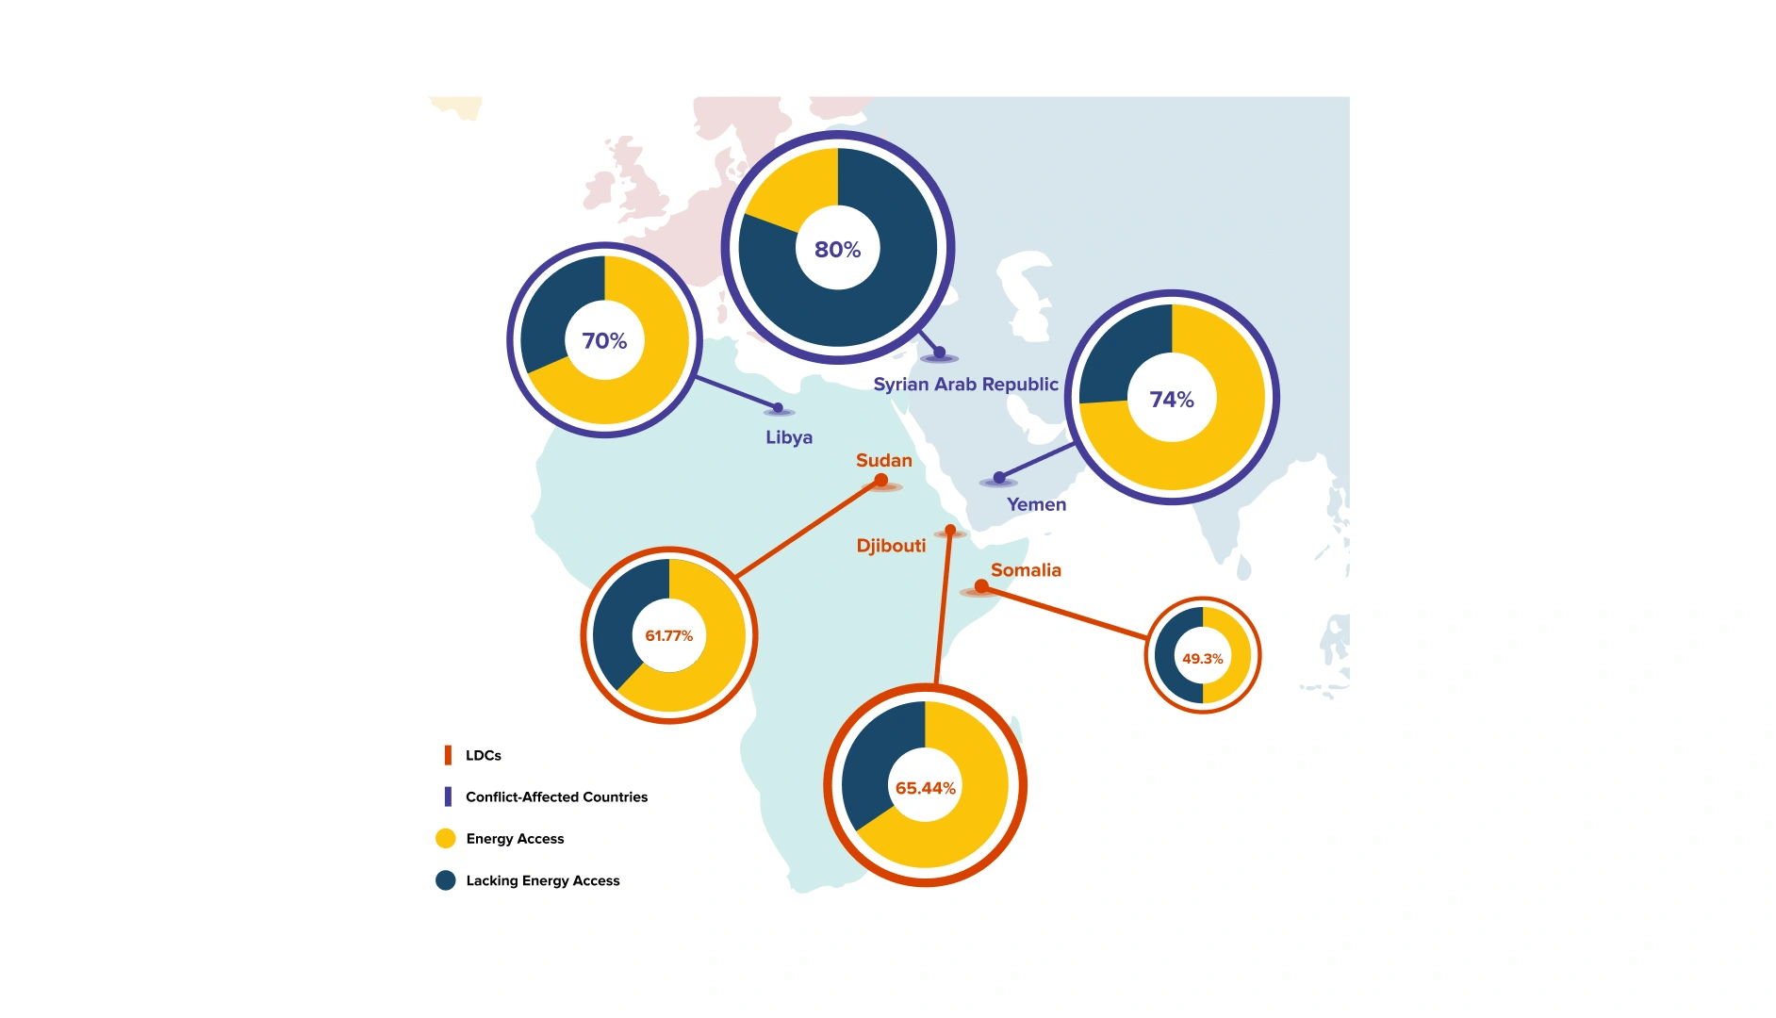
Energy Access in LDCs and Conflict Affected Countries within the Arab States Region
Reliability, affordability of electricity supply is the region’s most pressing energy issue
The region’s more pressing energy issue tends to be the quality of electricity supply, particularly in terms of reliability and affordability. Many countries may struggle with electricity blackouts and high or fluctuating electricity prices that are sensitive to inflation. For example, while Iraq and the State of Palestine have official energy access rates higher than 97 percent, electricity is intermittent with power outages sometimes lasting for several hours a day. Recent years in Lebanon have seen power outages become routine, with the state utility often providing only a handful of hours of electricity per day.
Unreliable and unaffordable energy can have several negative downstream effects for every system and sector that relies on electricity. This instability may cause individuals and businesses to rely on stop-gap solutions such as diesel generators. While generators provide consistent hours, they also emit toxic pollution and lower air quality.
Natural gas responsible for 72% of electricity generation
Natural gas and oil are still the largest sources of energy in the Arab region, particularly given the concentration of producers in the region. Electricity generation in the Arab States is fueled mostly by natural gas at 72% followed by oil at 25%. In contrast, only 7% of electricity is sourced from renewable energy.
The electricity and heat sector was responsible for 39% of total carbon emissions in the region as of 2022. This is significantly higher than other sectors, such as transport (21.9%), industry (19.4%), and so on.
M1: Introduction to Sustainable Energy System Transformation
C: Energy Opportunities in the Arab States
The widespread use of energy subsidies in the Arab region complicate the energy transition. Energy subsidies are offered to citizens in an effort to promote social welfare. However, these subsidies tend to limit efforts to promote renewable energy and energy efficiency 💬️. In 2020, nine Arab countries spent $75 billion on energy subsidies.
Additionally, energy subsidies impose a heavy fiscal burden on government spending and constrain resources for other priorities. For example, Libya spent 4.9% of its GDP and Algeria 1.6% of its GDP on energy subsidies in 2020, according to the 2023 Arab Future Energy Index (AFEX) report.
- $75 billion
spent by 9 Arab countries
on energy subsidies in 2020 alone
However, unprecedented reform in energy subsidies present opportunity for the energy transition
Despite the deep prevalence of energy subsidies in the Arab region, unprecedented reforms have taken place in the last decade. Eleven countries had undertaken energy subsidy reforms by 2017 compared to only six countries in 2014. Bahrain, Libya, and Saudi Arabia reduced electricity subsidies dramatically from 2010 to 2020. Tunisia intends to progressively phase out electricity and gas subsidies. Algeria is the only country that has increased the amount of electricity subsidies. Subsidy reform in particular can increase energy efficiency, as individuals and people are encouraged to be more economic with consumption habits.
Hydropower, already a main player, holds promise for meeting clean energy targets
Hydropower plays a dominant role in today’s renewable energy landscape in the Arab States. In the electricity sector, about 7% of energy comes from renewables. Out of that, most of it is specifically from hydropower at 3.4%. It has the largest installed capacity at 11.2 GW.
Given its present dominance, hydropower can be a powerful force in shaping energy transition opportunities in the Arab region. It is already supercharging energy transition targets. Take Sudan for example, where hydropower has helped clean energy achieve 52% of its total energy share, more than any other Arab state. Additionally, governments are factoring hydropower into future energy planning. Morocco intends to make hydropower meet 3.1% of its total energy needs to meet its net zero by 2050 target.
Increase in renewables capacity concentrated in Solar PV
The Arab region has multiplied its renewables capacity by tenfold over the past decade. The total installed renewable energy capacity is at 23.6 GW, with 5.1 GW added from just 2018 to 2020. The capacity increase has been concentrated in a few countries, such as Egypt, Jordan, and Morocco. It also has been mostly for PV, with capacity more than doubling from 3.2 GW in 2018 to 7.4 GW by the end of 2020. In contrast, wind energy 💬️ and CSP saw only minor increases.
Notably, part of the installed capacity could come from oil and gas producing countries, which have increasingly turned to solar PV to supply local electricity. These PV efforts are intended to conserve oil and gas reserves for future export revenues.
M1: Introduction to Sustainable Energy System Transformation
D: Energy Strategy in the Arab States
Thirteen Arab countries have national energy strategies as of 2023. Additionally, the region collectively has set a target for renewables to comprise 30 percent of the total energy mix by 2030.
National targets for installed capacity for renewables by 2030 include:
Saudi Arabia has the most ambitious target of 58.7 GW (30 percent of the energy mix) by 2030.
Bahrain has a National Renewable Energy Programme developed with UNDP support.
Egypt has a target of 59.7 GW (8.1 GW, concentrated solar power (CSP); 31GW, PV; and 20.6 GW, wind) by 2035.
Morocco plans to reach 100% of its electricity needs through:
- Rooftop solar at 29.1%
- Solar plants at 10.5%
- CSP at 4.8%
- Onshore wind at 41%
- Offshore wind at 10.5%
- Wave energy at 1%
- Hydropower at 3.1%.
Iraq announced an increase in the share of renewable energy to 33 percent by 2030. This target was set based on a recent expansion in solar projects.
Additionally, 11 Arab countries have adopted national energy efficiency plans.
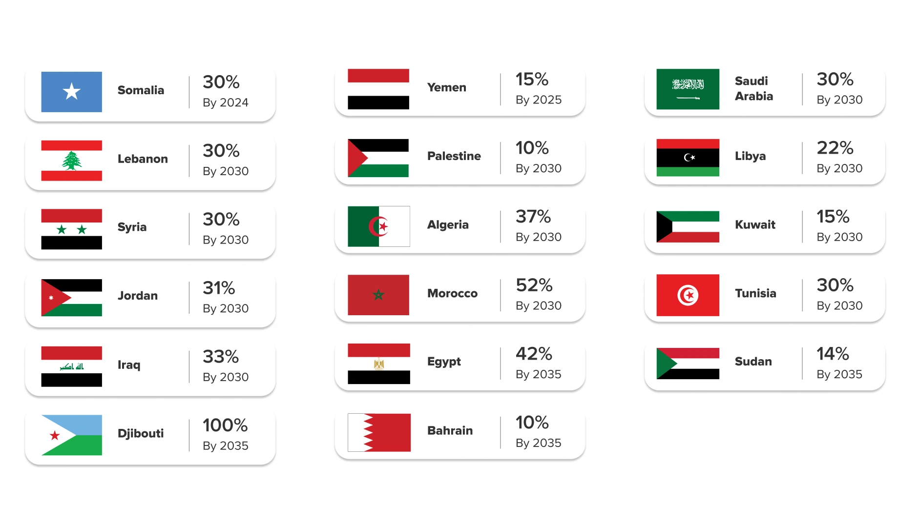
National Renewable Energy Targets in the Arab Region
Renewable energy investments increased 400% in the past decade
Renewable energy investments increased nearly 400 percent over the past decade in the Arab region, from $2.2 billion in 2010 to $10.9 billion in 2020. Investment figures are for utility-scale and small-scale solar projects and exclude large hydropower projects. This boost has been facilitated by the falling cost of renewable energy, different supporting schemes and excellent renewable energy potential.
Investments are expected to keep growing steadily, given ambitious renewable energy targets, experience from implementing utility-scale projects and growing commercial viability. Ten countries have financing mechanisms to subsidize energy efficiency programmes. Additionally, unlike many countries in other parts of the world, only a few Arab countries offer tax incentives for energy efficiency investments.
However, the lack of financing remains one of the biggest hurdles to reducing energy consumption in the Arab region. Arab countries face challenges related to governance, human capacity gaps and the coordination of institutions required for a systemic approach to energy.
Some Arab countries exempt renewable energy equipment from tariffs
Arab countries apply exemptions from customs duties for renewable energy equipment based on varying regulations. Examples can be found in Egypt, Jordan, Libya, Morocco, the State of Palestine, Sudan and Tunisia. In Egypt, the importer must obtain a certificate verifying that imported equipment is to be used for renewable energy projects. Tunisia has allowed duty exemptions for renewable energy components that do not have locally manufactured substitutes. In Morocco, large-scale investment projects over 200 million Moroccan dirham (approximately $21.3 million) can enjoy duty and value-added tax exemptions on all imported equipment, materials, and tools.
Key Takeaways
Significant access gaps exist; However, the region’s main challenge lies with energy quality At a 91% energy access rate, the region’s main challenge lies with reliability and affordability of energy supply. However, access gaps are prominent in LDCs and conflict-affected countries
Low renewable use today, but increasing capacity for tomorrow Only 7% of energy in the region flows from renewable sources. However, capacity has multiplied tenfold over the past decade, totaling about 23GW.
Financing remains a significant hurdle, even as renewable energy investments increase Arab countries face challenges related to governance, human capacity gaps and the coordination. However, renewable energy investments have increased to $10.9 billion in 2020, aided by tariff exemptions.

Lesson 1.3.2: Lesson 2: Latin America and the Caribbean
Lesson
Latin America and the Caribbean
M1: Introduction to Sustainable Energy System Transformation
Lesson 2 Overview
Latin America and the Caribbean stand at a pivotal crossroads. The region is endowed with some of the richest renewable energy resources in the world – abundant solar in Mexico and Chile, strong winds in Patagonia, expansive hydro resources in Brazil and the Andes, and emerging geothermal and green hydrogen opportunities. At the same time, it grapples with persistent inequality, energy poverty, climate vulnerability, and slow investment flows.
This lesson explores how the region’s vast energy potential can be harnessed to drive inclusive and sustainable development. Energy is not just a sector – it is an enabler. It powers schools and clinics, fuels jobs and industrial growth, supports digital inclusion, and provides resilience against disasters and shocks. Yet, 17 million people still lack access to electricity, and 78 million rely on traditional fuels for cooking – exposing deep energy access gaps that must be addressed if the region is to achieve the SDGs.
Despite having one of the cleanest electricity mixes globally (over 60% renewable), LAC remains heavily reliant on fossil fuels for transport and industry. The challenge now is twofold: ensuring universal access to modern energy and shifting energy systems toward resilience, equity, and sustainability.
By combining regional data, policy analysis, and forward-looking opportunities, learners will gain a holistic view of why sustainable energy is a cornerstone for economic transformation, climate action, and social justice across Latin America and the Caribbean.
M1: Introduction to Sustainable Energy System Transformation
A: Development Context in Latin America and the Caribbean
Latin America and the Caribbean is a region marked by both rich natural resources and persistent development challenges. While it boasts one of the cleanest electricity matrices globally – 41% hydropower, 8% wind, 6.2% solar – this green advantage coexists with structural inequalities, fiscal constraints, and energy poverty.
LAC remains one of the most unequal regions globally. Countries like Brazil, Chile, and Mexico have some of the highest inequality rates in the world.
Approximately 80% of the population live in urban areas, and the region faces unique vulnerability to natural disasters and climate shocks – 152 million people were affected by 1,205 natural disasters between 2000 and 2019. At the same time, the region holds exceptional potential in hydropower, solar, and wind, presenting a rare opportunity to leapfrog into a clean and just energy future.
Despite energy wealth, over
- 78 mln
people still lack access to clean cooking 💬️ and around 17 million people lack access to electricity, primarily in rural and remote areas.
The region's renewable energy potential, combined with smart finance, inclusive policies, and industrial innovation can transform these vulnerabilities into engines for inclusive growth and climate resilience.
M1: Introduction to Sustainable Energy System Transformation
B: Energy Challenges in Latin America and the Caribbean
The region has achieved a high electricity access rate of 97.6% as of 2021, but these gains are uneven.
17 million people, mostly in rural and Indigenous communities, remain unelectrified. In Haiti, for instance, only 47% of people have electricity access, and just 5% have access to clean cooking solutions.
Access is not just about lighting homes – it's about enabling education, health care, livelihoods, and climate adaptation. Last-mile electrification strategies, decentralized renewable systems, and digital tools (e.g., pay-as-you-go solar) present immediate and scalable solutions to enable a just energy transition 💬️
78 million people lack access to clean cooking, severely impacting health and disproportionately burdening women and girls.
Development Opportunity: Expanding energy access improves education, health, productivity, and gender equality. In rural areas, modern energy solutions reduce women's time poverty 💬️ and improve economic opportunities. Solar mini-grids, digital pay-as-you-go models, and off-grid solutions are transforming energy access across Latin America and the Caribbean.
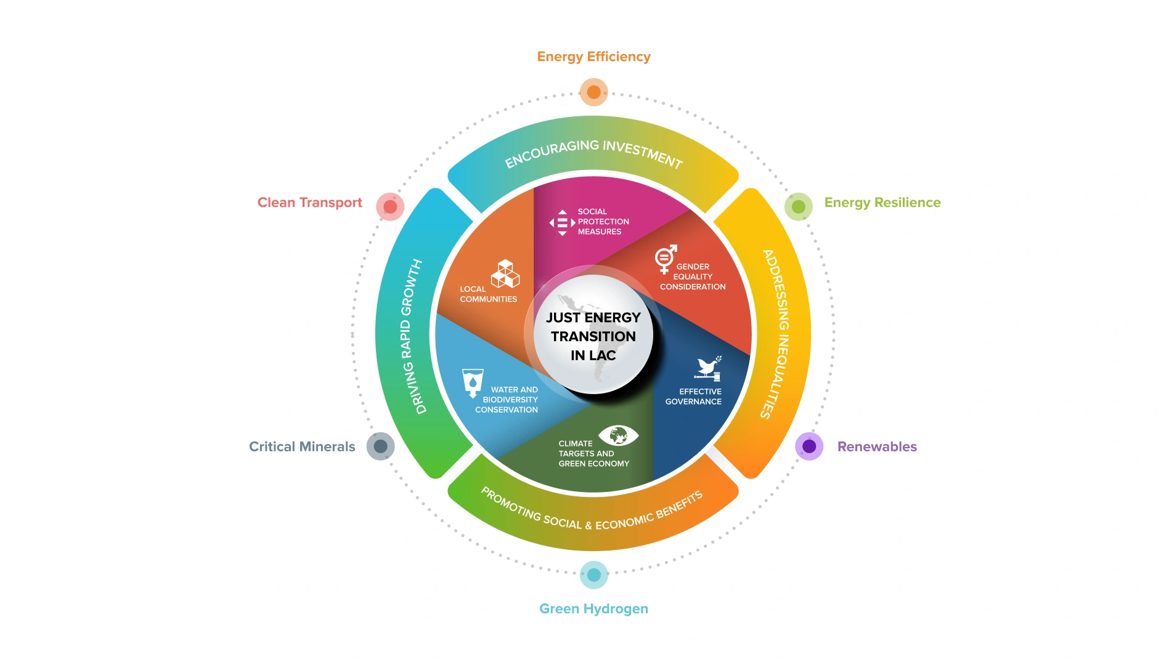
Just Energy Transition in LAC
Summary of the diagram. Otherwise, feel free to remove it.
LAC is uniquely positioned for a low-carbon transition. Renewable energy investments have soared, with solar and wind driving new capacity installations. However, fossil fuels still account for 66% of primary energy supply in the entire region and over 90% in the Caribbean.
Scaling renewables is not only about decarbonization 💬️ for he region – it's an engine for job creation and industrial transformation. The region could generate millions of green jobs if policy, finance, and local innovation are aligned. ECLAC estimates that 1.33% of GDP annually from 2021-2032 could make energy sources 86% renewable and cut GHG emissions by 30%.
Additionally,
In Energy Efficiency: Despite a 17% drop in energy intensity over 30 years, efficiency gains are slow. The building and transport sectors are ripe for scalable improvements.
In Green Hydrogen Potential: With low-cost renewables, LAC can become a global green hydrogen hub. Countries like Chile, Brazil, and Uruguay are leading with over 25 pilot projects under development.
M1: Introduction to Sustainable Energy System Transformation
C: Energy Opportunities in Latin America and the Caribbean
The region has made significant progress towards
achieving SDG 7, on affordable and clean energy.
Last-mile access strategies are steps towards
universal access to electricity and clean cooking
solutions. Inflation and high energy prices affect
access and affordability, however, especially for the
most vulnerable communities.
Despite challenges, rich biodiversity and
opportunities in the bio-economy serve as crucial
drivers for development in Latin America and
the Caribbean. The region possesses distinctive
comparative advantages in pioneering innovation
and harnessing abundant natural resources,
including in leading the way towards green
hydrogen, renewable energy, clean transportation
and a just energy transition.
A just energy transition could have a positive impact
on economic growth by boosting productivity and
generating green jobs.
It also holds potential to
create more opportunities for women to participate
in new segments of the labor force, if discriminatory
barriers in pay, job opportunities and unpaid care work are addressed. Green jobs present a distinct
opportunity to leverage abundant renewable energy resources.
Need for Increasing Renewables Capacity
The region lags others in terms of renewable energy production. However, there is promise to be found in the region’s increasing capacity for renewables, which has multiplied tenfold over the past decade.
The total installed renewable energy capacity is at 23.6 GW, with 5.1 GW added from just 2018 to 2020.
The capacity increase has been concentrated in a few countries, such as Egypt, Jordan, and Morocco. It also has been mostly for PV, with capacity more than doubling from 3.2 GW in 2018 to 7.4 GW by the end of 2020. Wind energy and CSP saw only minor increases. Perhaps unexpectedly, oil-producing countries have also increasingly turned to solar to supply local electricity, with several mega-scale projects under development. This is part of efforts to conserve oil and gas reserves for future export revenues.
Four key priority areas have been identified for the region
a. Closing the Energy Access Gap
Enhancing energy access is directly linked to reducing multidimensional poverty. Households with energy access experience improved educational outcomes, health, and productivity.
Digital payment models (e.g., pay-as-you-go solar) and community-led electrification are scalable across off-grid and rural areas.
b. Accelerating a Just Energy Transition
Transitioning to renewables could cut emissions by 30% and make the energy mix 86% renewable by 2032 with just 1.33% of GDP annual investment.
It also creates gender-responsive employment opportunities and reduces inequality if designed inclusively.
c. Strengthening Energy Resilience
Caribbean states spend up to 1.2% of GDP on natural disaster recovery annually. resilient infrastructure 💬️ – especially solar mini-grids – can protect critical services during disasters.
d. Driving Energy Finance and Investment
Only 1.3% of regional GDP goes to fossil fuel subsidies, a significant fiscal burden. Redirecting subsidies to clean investments could generate better returns, equity, and environmental benefits.
Regional development banks and local financial institutions (with nearly $1 trillion in assets) are crucial for unlocking blended finance and de-risking projects.
Financing is critical
Globally, clean energy investments reached $1.3 trillion in 2022, but only a small share goes to Latin America and the Caribbean (LAC), which needs $125–200 billion annually to meet SDG 7 targets.
Innovative tools like blended finance, green bonds 💬️, and concessional loans—backed by public funding through mechanisms such as the GEF and GCF—are vital to mobilize private capital. National development banks also play a crucial role. Well-structured finance can catalyze inclusive development by supporting energy access, productivity, e-mobility, climate-resilient agriculture, and circular economies.
What is the most likely failure mode when scaling renewable energy projects in Latin America and the Caribbean?
- Supply chain disruptions delaying critical components
- Stakeholder opposition hindering project acceptance
- Policy instability causing regulatory uncertainties
- Technological incompatibilities hindering integration
Key Takeaways
Energy Poverty Persists in Marginalized Areas, especially in the Caribbean and Rural Zones. While LAC reports a high overall electricity access rate (97.6%), over 17 million people remain without electricity, and 78 million still lack access to clean cooking, with the Caribbean and Indigenous communities facing the deepest gaps.
The Region Has One of the World’s Cleanest Grids but Still Relies Heavily on Fossil Fuels LAC generates more than 60% of its electricity from renewables, particularly hydropower, yet fossil fuels still dominate the overall energy mix (66%), especially in transport and industry
Unlocking Finance and Building Resilience Are Central to a Just Energy Transition The region requires $125–200 billion annually to meet SDG 7 targets and build climate-resilient energy systems.

Lesson 1.3.3: Lesson 3: Africa
Lesson
Africa
M1: Introduction to Sustainable Energy System Transformation
Lesson 3 Overview
Despite its current energy challenges, Africa has
Vast renewable energy potential and a rich reserve of critical minerals (like cobalt, lithium, and rare earth elements) that are vital to the global clean energy transition.
A strategic opportunity to leapfrog to modern, green energy systems, closing the electricity and clean cooking access gaps that affect over 900 million people in Sub-Saharan Africa.
The chance to create inclusive, low-carbon economies, enabling job creation, skills development, and industrialization while prioritizing gender equality and youth empowerment.
This lesson discusses the African context by exploring Africa’s energy and economic situation. Furthermore, it highlights the development focus for the region, having discussed its particular challenges.
M1: Introduction to Sustainable Energy System Transformation
A: Development Context in Africa
80% of people without electricity in sub-Saharan Africa live in rural areas
Africa’s rural-urban divide presents a major challenge to sustainable development, particularly in the energy sector. While urban areas increasingly benefit from grid connectivity and infrastructure investments, rural communities remain disproportionately underserved—over 80% of people without electricity in sub-Saharan Africa live in rural areas. This imbalance, also seen in the measure of clean energy equity index across the region, hinders poverty reduction, limits access to education and healthcare, and exacerbates migration pressures toward cities. Addressing this divide is critical for achieving the Sustainable Development Goals (SDGs), especially SDG 7 on affordable and clean energy.
By 2050, Africa is projected to account for 25% of the world’s population.
Africa is poised to become a central player in global energy markets 💬️, projected to account for 25% of the world’s population by 2050, with rising urbanization, middle-class consumption, and growing demand for clean energy.
Africa offers some of the highest returns on renewable energy investments globally (IRENA, 2022)
With strong governance and climate finance, Africa is not just a future energy market—it is the frontier of energy growth.
Over 60% of Africa’s population is under 25
Yet youth unemployment remains high and technical skills are lacking. Addressing this skills gap through vocational training, technical education, and green innovation hubs will be essential to enable youth and marginalized groups to fully participate in and benefit from the renewable energy transition.
M1: Introduction to Sustainable Energy System Transformation
B: Energy Challenges in Africa
Across the globe, energy poverty remains a persistent barrier to development, with 666 million people still lacking access to electricity and 2.1 billion without access to clean cooking 💬️ solutions. Nowhere is this challenge more acute - and more urgent - than in Sub-Saharan Africa.
In this region alone, 565 million people live without electricity, representing 83% of the global electricity access deficit.
Countries like Nigeria, the Democratic Republic of Congo, and Ethiopia are home to nearly one-third of the world’s population without electricity. This isn't just a statistic, it reflects hundreds of millions of people whose daily lives, economic potential, and health are compromised due to the absence of reliable energy.
Access to clean cooking in Sub-Saharan Africa is a critical and urgent issue.
Approximately 923 million people—nearly half of the global population lacking clean cooking—still depend on wood, charcoal, or other biomass fuels. These are typically burned in open fires or traditional stoves, leading to severe health risks from indoor air pollution, especially for women and girls who also spend long hours collecting fuel. Addressing this challenge can yield multiple benefits: better health outcomes, enhanced gender equality, and reduced environmental degradation. Achieving universal energy access in Africa could also boost GDP growth by up to 6% annually in some countries (World Bank, 2022).
Africa’s economy remains heavily reliant on fossil fuels with 12 countries holding proven oil reserves—Libya, Nigeria, and Angola alone account for about 5% of global reserves.
In these nations, oil and gas make up over 85% of export earnings, leaving their economies vulnerable to global market fluctuations. Despite this wealth, human development remains low in many fossil fuel-rich countries, such as Chad (HDI 0.394), Republic of Congo (0.479), Nigeria (0.535), and Tanzania (0.549).
Notably, 62% of the world’s poor now live in Sub-Saharan Africa’s resource-rich economies, a sharp rise from 13% in 2000, highlighting that fossil fuel dependence has not led to inclusive or sustained development. Although recent geopolitical events, like the energy crisis from Russia’s invasion of Ukraine, have temporarily boosted African gas demand, this is not a long-term fix.
Additionally, fossil fuel extraction in Africa is 15-20% more costly and 70-80% more carbon-intensive than elsewhere, increasing risks of stranded assets as global fossil fuel demand falls and debts rise.
Amid these challenges lies a significant opportunity: investing in renewables such as solar, wind, mini-grids, and clean cooking technologies can bridge energy access gaps while fostering economic diversification, stability, and inclusion. Renewable infrastructure supports supply chains and skilled labor, enabling job creation and new markets, especially in underserved rural and peri-urban communities through local solar and off-grid providers.
66% of the world's cobalt
with the DRC as the largest producer
10% of copper
with Zambia as the largest producer
30% of lithium
with DRC and Zimbabwe as the largest producers
15% of rare earth reserves
with DRC as the largest producers
95% of chromium
with South Africa as the largest producer
30% of manganese
Except for cobalt – where the DRC accounts for approximately 70% of global production – Africa's contribution to global production remains relatively small.
With responsible mining practices, Africa can actively participate in the development of value-added products during the energy transition
Processing operations are primarily concentrated in China, accounting for 35% of nickel, 50-70% of lithium, and cobalt, and 90% of rare earth elements. For instance, Zimbabwe, the sixth-largest global lithium producer, could potentially supply up to 20% of the global lithium market, but currently only accounts for 1% of global lithium supply.
M1: Introduction to Sustainable Energy System Transformation
C: Energy Opportunities in Africa
Africa’s renewable abundance makes it one of the most competitive regions for green hydrogen production
Countries like Namibia, Mauritania, Egypt, and South Africa are developing large-scale hydrogen projects.
Green hydrogen can power industries, replace imported fertilizers, and serve as a clean fuel for export, particularly to Europe.
Africa could produce up to 5,000 megatonnes of hydrogen per year at less than $2/kg by 2050 - equal to the world’s current energy supply (IEA, 2023).
This could position Africa as a global supplier of sustainable fuels, creating high-tech industries and boosting export revenues.
Africa’s role in the global economy could be redefined
76% of Africa’s electricity generation could be renewable by 2040, if the right investments and policy frameworks are adopted (IRENA, 2021).
Africa holds 30% of the world’s essential minerals required for renewable technologies such as lithium, cobalt, and rare earth elements - critical for batteries, wind turbines, and solar panels (IEA, 2023).
The continent also possesses 60% of the world’s best solar resources, making it uniquely positioned to become a global renewable energy leader (IRENA, 2022).
This clean energy potential could redefine Africa’s role in the global economy - transforming it from an exporter of raw resources into a hub of green industrialization, innovation, and resilience.
Africa need more installed electricity capacity
Currently, Africa’s installed electricity capacity stands at 369 gigawatts (GW)—only 16% of China’s capacity. The average per capita electricity consumption in Sub-Saharan Africa is a mere 200 kWh per year, barely enough to power a few lightbulbs and a small fan. For comparison, China’s consumption is 4,500 kWh, India’s is 1,300 kWh, and Brazil’s is 2,360 kWh. Experts estimate that at least 1,000 kWh per person per year is needed to sustain a path of productive economic development.
Although progress has been made over the past decades, much more needs to be done, especially to obtain a normal and not skewed distribution between the states in the region - South Africa and Egypt alone account for nearly 50% of total electricity production in the region. While Africa accounted for only
- 3%
of total global electricity production in 2022
Off-Grid and Decentralized Power are game changers
With over 80% of Africa’s unelectrified population in rural areas, off-grid solar, mini-grids, and battery storage systems are game changers.
Companies like M-KOPA and d.light are already reaching millions of households with pay-as-you-go solar kits.
decentralized energy systems 💬️ can bypass the cost and time of grid extension, offering faster, cleaner access to power.
These solutions create opportunities for local entrepreneurship, digital payments, and financial inclusion..
Financial investment is critical
To achieve universal energy access by 2030, Africa must secure $25 billion in annual investments
Yet, between 2000 and 2020, the continent attracted just 2% of the $2.8 trillion invested globally in renewables, highlighting a significant financing gap.
Scaling up energy finance is not only essential for climate goals but is also a development priority, especially as fossil-fuel-dependent economies face increasing risks. Renewable energy offers Africa a chance to diversify economically, foster resilience, and transition to a digital, climate-smart economy.
African Union Agenda
The AU’s Agenda 2063 already sets an ambitious aspiration to realize
This vision is rooted in the need to deliver energy security through interconnected infrastructure and a shift towards “modern, efficient, reliable, cost-effective, renewable and environmentally friendly” energy systems.
Industrial and Supply Chain Development
Africa’s mineral wealth, if harnessed responsibly, can form the backbone of local and regional manufacturing:
Countries like the DRC (70% of global cobalt) and Zimbabwe (significant lithium reserves) can establish local processing and battery manufacturing industries.
Regional supply chains can be developed for solar panels, wind turbines, batteries, and electric vehicles, fueling local economies and reducing import dependency.
This would move Africa up the value chain, away from raw exports and towards job-rich, high-value production, attracting foreign direct investment.
Regional cooperation can make energy solutions more cost effective.
Initiatives such as the West African Power Pool, which cover 14 out of 15 countries in the region’s economic block, attempts to integrate national power systems into a unified regional electricity market.
Development of the Lobito Corridor, spanning DRC, Angola, and Zambia, can strengthen regional supply chains related to batteries
What is a major challenge for expanding renewable energy in Africa despite its abundant resources?
- Limited infrastructure for grid integration
- Overdependence on imported technology
- High transmission costs across urban areas
- Lack of community awareness on renewables
Key Takeaways
Africa’s Energy Landscape Faces Deep Challenges but Offers Immense Potential. The continent has significant renewable energy potential and critical minerals needed for clean energy technologies, positioning it as a key player in the global energy transition.
The Economic Reality Underscores the Need for a Just Transition Only 2% of global renewable energy investments between 2000–2020 went to Africa — highlighting the need for massive, targeted financing.
UNDP’s Regional Strategy Provides a Framework for Equitable Energy Transformation It promotes six enabling activities, including energy finance, digitalization, effective governance, innovation, skills training, and gender mainstreaming.

Lesson 1.3.4: Lesson 4: Asia and the Pacific
Lesson
Asia and the Pacific
M1: Introduction to Sustainable Energy System Transformation
Lesson 4 Overview
Asia and the Pacific is the largest region with 4.7 billion people from vastly different walks of life. With two of the world’s largest and growing economies, this region represents the future of both energy consumers and sustainable energy suppliers.
This lesson will explore the energy landscape in the UNDP’s Regional Bureau of Asia and the Pacific (RBAP), which is made up of 36 countries. This includes the trends that define development progress, challenges in energy access and quality, opportunities for growth, and strategic goals for the short and long-term.
M1: Introduction to Sustainable Energy System Transformation
A: Development Context in Asia and the Pacific
More than half the world’s population is in Asia-Pacific
The Asia and the Pacific region is vast with 4.7 billion people, more than half of the world’s population, spread across 58 countries and territories. It is also economically diverse, including the world’s largest energy consumer to small island states that are among the most vulnerable to the impacts of climate change. Given its sheer size, Asia and the Pacific plays a pivotal role in shaping the global energy future.
Industrialization has transformed job markets, with extreme poverty dropping to 5% in 2019 compared to 22% in 2022
Over the past few decades, industrialization has transformed job markets in the Asia and the Pacific region. Jobs have moved from agriculture towards the industry and services sectors. Sixty percent of China’s workforce was involved with the agricultural sector in 1991. That percentage dropped to 25% by 2019. Vietnam’s workforce share in agriculture was 75% in 1991, but dropped to 35% by 2019.
Industrialization has contributed to strong economic growth and extreme poverty reduction over the past two decades. More than 22% of the region’s population lived on less than $1.90 USD per day, considered extreme poverty, in 2000. This share dropped to 5% by 2019.
Additionally, China has ushered in the green industrial revolution. The country plays a leading role in clean energy supply chains, with an over 80% share in manufacturing capacity across the global solar PV supply chain.
Although the Asia-Pacific region boasts the world’s lowest unemployment rate, more than 2/3 of its workforce are informally employed. Unemployed workers frequently earn low wages and are subject to unstable and poor working conditions.
This affects young people significantly. People between the ages of 15 to 24 are five times more likely to be unemployed than adults in the region. Therefore, energy transition policy should emphasize job creation with well-paid and stable working conditions.
- 2 out of 3
workers are informally employed in Asia and the Pacific
The region is experiencing rapid urbanization, but local governments lack resources for long-term planning
Over 50% of the region’s population lives in urban areas. This trend is accelerating rapidly, at a rate higher than the global average. By 2050, an estimated 2.9 billion people in the region are expected to live in urban areas.
Rapid urbanization demands a strong focus on sustainable development. Local governments must plan for efficient land use, reduce embodied carbon in construction, and develop infrastructure for transport. All of these goals will require energy, and it is imperative the solutions brought forward focus on renewables and circular economy 💬️.
M1: Introduction to Sustainable Energy System Transformation
B: Energy Challenges in Asia-Pacific
Asia-Pacific leads global progress on energy access, but key gaps remain
The region has near universal electricity with a 99% access rate in 2021. That is up from a 94% access rate in 2016. In fact, much of the progress in reducing the global energy access gap was driven by improved access rates in Asia, particularly in India and Bangladesh.
Despite this progress, Myanmar, Pakistan, and North Korea still have about 40 million people without electricity. Additionally, around 50 million people across Asia and the Pacific, mainly in rural low-income areas, still lack reliable electricity, highlighting the need for focused policies on last-mile access and quality.
Access to clean cooking improved from 51% in 2010 to 74% in 2021. Yet there are still access gaps for around 1.2 billion people, especially in rural areas and small island developing states 💬️. Challenges to greater clean cooking adoption include: technology, affordability, investment and cultural preferences.
Clean cooking significantly benefits health by reducing indoor air pollution, mainly affecting women and children. It also lessens women’s time poverty by easing firewood collection and improving cooking efficiency.
To advance clean cooking, integrating social policies into regional energy plans is vital. Affordability can be boosted through targeted subsidies and micro-finance, with cleaner fuels like LPG offering practical rural solutions. Programs in India, Indonesia, and Bhutan are driving transitions from traditional to cleaner cooking methods, including India’s LPG subsidies specifically targeting female-headed households and promoting women’s financial inclusion.
Coal dominates electricity generation
Coal powers 58% of electricity generation in Asia and the Pacific. In turn, the electricity and heat sector is responsible for 53% of the region’s CO2 emissions. This underscores the urgent need for diversifying energy sources in the electricity sector to both meet climate targets and ensure resilience of the sector.
Growing economies such as India and China are driving energy demand
India and China are major drivers of energy demand in Asia and the Pacific as their economies grow at rapid pace. Per capita greenhouse gas emissions are below the world average but projected to grow in the coming decades. Aside from the fast deployment of clean energy for growth, one other key is to increase energy efficiency 💬️. Despite progress in East Asia, the region overall remains one of the most energy intensive globally.
The region requires renewed and expanded power grids to accommodate investments in green energy. This restructuring presents challenges in both areas with established grids and those requiring off-grid solutions. Ultimately, the grids must extend to where people reside – connecting them to markets, schools, clinics, and homes – to prevent exclusion and ensure equitable development.
M1: Introduction to Sustainable Energy System Transformation
C: Energy Opportunities in Asia and the Pacific
Most renewable energy employment can be found in Asia-Pacific
Out of global renewable energy employment, the majority is situated in Asian nations, comprising 62% in 2022. China alone accounts for 41% of the global total. Among renewable energy technologies, solar PV is the fastest-growing sector, accounting for more than one-third of the total renewable energy workforce. However, green jobs are highly concentrated in a handful of countries. These jobs require the right skills and training, and this is a pre-investment that needs to thrive in this space. It is essential to retrain workers from fossil fuel industries and establish social safety nets during this transition, thereby creating additional opportunities.
The share of renewable energy in total final energy consumption has rapidly increased, surpassing 8.5% in 2018. The power sector saw the most notable growth, with renewables accounting for 22.1% of electricity generation in 2018, up from 16.1% in 2010. Globally, the renewable energy mix rose from 16% in 2010 to 19% in 2020. Within Asia and the Pacific, sub-regional disparities exist with the highest renewable shares in East and Southeast Asia and the lowest in the West.
- 21.1%
of electricity generation came from renewables in Asia and the Pacific in 2018
Circular economy principles can reduce critical minerals 💬️ dependency
Asian countries hold a critical manufacturing base that can support the energy transition yet they are also highly dependent on critical minerals imports. Deploying lifecycle and circular economy principles can reduce regions dependency for newly mined critical materials.
These include:
Safe and green design
Product re-engineering with large quantities of minerals
Green standards
Policies to increase the share in the use of collected and recycled materials, plastics, and other materials
Deployment of effective Extended Producer Responsibility (EPR) schemes
Improve waste management systems to improve collection and recycling rates
Such approaches would also reduce e-waste and its negative downstream impacts. Additionally, when designed through a social inclusion lens, these efforts can further boost decent job creation for women, youth, and marginalized groups including informal sectors, especially in waste management.
China can assist in technology transfer 💬️, knowledge-sharing through regional cooperation schemes
Regional collaboration is emerging as a key solution to advancing the energy transition in Asia and the Pacific, enabling countries to share knowledge, technologies, and policy best practices tailored to common development challenges. South-South cooperation plays a critical role by fostering peer learning, capacity-building, and the transfer of sustainable energy technologies. For example, China’s leadership in hydrogen innovation and investments in carbon capture, utilization, and storage (CCUS) offers valuable opportunities for other countries in the region to benefit from pilot projects and advanced technologies. By strengthening partnerships with regional actors like ADB, AIIB, UNESCAP, and APEC, countries can collectively accelerate the shift to low-carbon, resilient energy systems through inclusive, evidence-based collaboration.
Increased efficiency can reduce cooling demand
The cooling agenda is increasingly prioritized by governments globally and across Asia-Pacific. The International Energy Agency identifies rising air conditioner demand as a major overlooked issue in energy discussions. The IEA’s Efficient Cooling Scenario projects that better policies could double AC efficiency and cut cooling energy demand by 45% versus the baseline. This would reduce the need for new power plants to meet peak demand, particularly at night. Cooling is also critical for sectors like food cold chains and health, especially vaccine supply chains, yet many countries still have low cold chain penetration, leading to high food waste. Supporting efficient cooling in these sectors promotes SDGs in health and food security while managing energy use. Women’s significant roles in food processing and retail mean investing in efficient cooling can also boost their economic empowerment and livelihoods.
Sustainable mining for critical minerals is increasingly important to national economic agendas
The growing importance of sustained access to critical raw materials—key for the energy transition—is becoming a priority on national economic agendas. As the demand for greener energy technologies accelerates, it affects the entire mining and raw materials value chain across all sectors. UNDP’s existing work on sustainable mining positions it well to address these challenges. Once the UN’s official framework on Critical Energy Transition Minerals is released, it will guide solutions to supply chain issues, governance, social protection 💬️, and gender equality, emphasizing human rights approaches. Potential solutions include promoting sustainable practices by redefining the value of natural resources and ecosystems, encouraging mining industries to minimize environmental harm, and restoring ecosystems after extraction. Additionally, UNDP’s Nature Pledge aims to redirect investments toward sustainable, resilient energy projects, including research and development in sustainable mining and energy-efficient technologies, supported by various incentives.
With investments focused on low-risk areas, East Asia and the Pacific thrive
Significant investments with a focus on mobilizing private finance are required to fund clean energy in Asia and the Pacific. Investments in renewable energy are still mainly focused on low-risk areas, with East Asia and the Pacific receiving the highest share of investment. In 2019-2020, this region attracted about 45% of the total investment. However, China accounted for over four-fifths of the investment in this region, driven by its government’s ambitious targets of reaching peak emissions by 2030 and achieving carbon neutrality 💬️ by 2060. The regional landscape for energy investments has changed significantly from traditional dependence on multilateral and bilateral assistance to more market-based financing solutions. Indeed, over 80% of the countries are now considered middle-income. This necessitates a greater reliance on market-based financing measures and a particular role for the private sector to mobilize investments and take a lead in energy infrastructure deployments, often against challenging post-COVID domestic and international financial market conditions.
What is a primary factor influencing the development of sustainable energy projects across Asia and the Pacific?
- Availability of renewable resources in the region
- Level of technological innovation in energy storage
- Public acceptance and community support
- Regional government policies and incentives
Key Takeaways
Energy Poverty Persists in Marginalized Areas, especially in the Caribbean and Rural Zones. While LAC reports a high overall electricity access rate (97.6%), over 17 million people remain without electricity, and 78 million still lack access to clean cooking, with the Caribbean and Indigenous communities facing the deepest gaps.
The Region Has One of the World’s Cleanest Grids but Still Relies Heavily on Fossil Fuels LAC generates more than 60% of its electricity from renewables, particularly hydropower, yet fossil fuels still dominate the overall energy mix (66%), especially in transport and industry
Unlocking private finance is especially important for the Asia-Pacific region Over 80% of the countries are now considered middle-income. This necessitates a greater reliance on market-based financing measures and a particular role for the private sector to mobilize investments and take a lead in energy infrastructure deployments

Lesson 1.3.5: Lesson 5: Eastern Europe and Central Asia
Lesson
Europe and Central Asia
M1: Introduction to Sustainable Energy System Transformation
Lesson 5 Overview
With competing pressures tied to climate impacts, war and displacement, and EU candidacy, energy in the Europe and Central Asia region represents a convergence of structural shifts. At the same time, regional countries may use the energy transition to leverage their rare earth metals and hydropower.
This lesson identifies key trends in the UNDP’s Regional Bureau for Europe and Central Asia (RBEC) that are critical to understanding its positioning in the energy landscape. This includes context on development, challenges and opportunities related to energy access and sustainable energy, and strategies within the region for how to proceed.
M1: Introduction to Sustainable Energy System Transformation
A: Development Context in Europe and Central Asia
In the region, 10 countries are candidates to join the EU
The European Union accession process is a strategic priority for many countries in the region; 10 are candidates to join the union. This is more than a technical process; it is a generational choice based on fundamental values. The Western Balkans and some of the Eastern European economies have an historic opportunity to align their future firmly and unequivocally with the European Union, which could bring significant economic and social benefits.
As of 2024, UNDP manages a robust energy portfolio in the RBEC region with 31 active projects totaling over $825.55 million and has implemented 63 clean energy projects benefiting 10.2 million people under its 2022-2025 Strategic Plan. Funded mainly by the Global Environment Facility, Green Climate Fund, and key bilateral donors like the EU, UK, and Japan, UNDP leverages its long-term regional presence and strong government, civil society, private sector, and academic partnerships to support national energy policies and promote a socially just clean energy transition. Its expertise includes innovative financial tools like green bonds and scaling energy efficiency 💬️ efforts at municipal levels, while maintaining a vital local presence during conflicts to aid affected populations and governments.
With some of the largest outward migration flows, the region is experiencing significant brain drain
The region has been significantly affected by ongoing conflicts, notably the war in Ukraine, leading to mass displacements and heightened social tensions. Outward and transit migration flows are among the highest globally, with many countries in the region experiencing extensive depletion of human capital. Impacts from the war in Ukraine have not only been felt in-country, but across the region, especially around energy, migration and supply chains. These crises have disrupted regional stability and challenged the rule of law. Since 2008, Eastern European nations have experienced a 6.9% decline in peace, largely due to escalating conflicts. Additionally, the region faces mixed progress in democratic governance, with undemocratic tendencies and centralized economies hindering reforms. Civic space has continued to shrink, accompanied by political polarization and a rise in hate speech and misinformation. However, the initiation of EU accession negotiations with countries like Bosnia and Herzegovina, Moldova, and Ukraine, along with the granting of candidate status to Georgia, presents opportunities to accelerate rule of law reforms.
Extreme weather is stressing the region’s electric grids
Heat waves and droughts in the region increase electricity demand while straining water resources vital for energy infrastructure, risking power shortages and higher operational costs. Most countries lack strategies for sustainable cooling and managing extreme heat, with water scarcity already affecting Central Asia and expected to worsen due to climate change. This drives growing demand for policies on energy-related water management and cooling. Extreme weather also threatens energy infrastructure through damage to power lines and substations. UNDP supports countries in developing climate adaptation policies, emphasizing the need for detailed risk assessments and sector-specific strategies to enhance resilience against climate impacts on energy systems.
M1: Introduction to Sustainable Energy System Transformation
B: Energy Challenges in Europe and Central Asia
1 in 3 people struggle to afford energy
Despite being home to the world’s largest hydrocarbon exporters, the RBEC region faces significant energy poverty, with about one in three people struggling to afford energy amid aging infrastructure and frequent power cuts in harsh winters. Electrification is nearly universal, estimated at close to 100%, but outdated systems require urgent modernization. The recent energy crisis and conflicts have worsened the situation— for example, in Moldova, 71% of households spend 90% or more of their disposable income on energy and heating during cold periods. This forces many to switch to cheaper but environmentally harmful heating options, highlighting the urgent need to address energy affordability and improve living conditions.
Heating is life-saving, but also energy-intensive
In the region, heating is critical during extremely cold winters, with district heating systems largely reliant on natural gas and coal, often subsidized but facing delivery challenges. Many households use individual gas boilers or local coal, and inefficient buildings consume two to three times more energy per square meter than Western Europe, making heating increasingly unaffordable. Heating accounts for about 24% of regional energy demand, with annual space heating at approximately 2,625 TWh—72% residential and 28% commercial/public. Residential energy use averages 160 kWh/m², far exceeding Canada (114), the EU27 (110), the US (70), and Japan (33). Despite inefficiencies, district heating remains vital due to its centralized infrastructure and economies of scale, and modernizing these systems to integrate renewables can reduce fossil fuel dependence, emissions, and costs while improving energy security and climate adaptability.
- 24%
of regional energy demand comes from heating
Transitioning to renewable energy and improving efficiency are key to reducing emissions in the Western Balkans, Central Asia, and the Caucasus, but progress varies due to differing fossil fuel dependencies. Countries like Azerbaijan, Kazakhstan, and Turkmenistan, major oil and gas exporters, face limited incentives to shift to renewables and require support in setting carbon neutrality 💬️ targets. Coal-rich regions such as Kazakhstan, Ukraine, and the Western Balkans need long-term assistance for a just transition. Hydropower dominates electricity generation in Albania (99.6%), Tajikistan (90%), Kyrgyzstan (85.5%), and Georgia (80.5%), yet despite strong solar and wind potential, establishing functional energy markets and scaling renewables remains a regional challenge.
M1: Introduction to Sustainable Energy System Transformation
C: Energy Opportunities in Europe and Central Asia
Previous water collaborations provide an example for regional grid integration
As part of the process of accession to the European Union, Georgia, Moldova, Ukraine and the Western Balkans are improving the interconnectivity of power and natural gas grids, both among themselves and with the Union. Such interconnectivity increases energy reliability and security, facilitating more resilient energy infrastructure. Candidate countries use national energy and climate plans to set mandatory targets for energy efficiency, renewable energy and cuts in greenhouse gas emissions, effectively integrating energy and climate policies. Strong previous collaborations on water security can provide effective frameworks.
The Carbon Border Adjustment Mechanism hurts exports, but could also catalyze the region’s green hydrogen production
The EU’s Carbon Border Adjustment Mechanism (CBAM) presents a significant challenge for RBEC countries by raising the cost of carbon-intensive exports—such as steel, cement, aluminium, fertilizers, and electricity—to the EU. Iron and steel lead exports at $16.5 billion, mainly from Türkiye, Ukraine, and Serbia, followed by aluminium at $5.9 billion, dominated by Türkiye. Fertilizer exports reach around $1.2 billion, and electricity exports totaled nearly $1.4 billion in 2022, primarily from the Western Balkans, Türkiye, and Eastern Neighborhood countries. While current hydrogen exports are minimal, rising EU demand may soon elevate its importance. Despite short-term trade impacts, CBAM also offers a strategic opportunity to accelerate decarbonization 💬️, with clean fuel investments—such as biomethane and renewable hydrogen—in Moldova, Ukraine, and the Western Balkans.
Hydrogen presents a growing energy opportunity for the RBEC region, despite currently negligible export levels under the chemicals category. With the EU’s Carbon Border Adjustment Mechanism (CBAM) increasing costs for carbon-intensive exports—iron and steel exports alone total $16.5 billion and aluminium $5.9 billion—there is strong incentive to decarbonize. EU initiatives like REPowerEU are supporting countries such as Moldova, Ukraine, and those in the Western Balkans to invest in producing and trading clean fuels, including renewable hydrogen, positioning hydrogen as a critical future export and energy solution to meet rising EU demand and enable a low-carbon transition in the region.
The region holds significant rare earth minerals
Central Asia and neighboring regions hold significant reserves of critical minerals 💬️ essential for the global energy transition, including 38.6% of the world’s manganese ore, 30.07% of chromium, 20% of lead, 12.6% of zinc, and 8.7% of titanium. Kazakhstan alone contributes 43% of global uranium production (2022) and 2% of global copper (2021), and has strong potential to rival China’s 70% dominance in rare earth element supply. The Western Balkans host some of Europe’s largest deposits of copper, chromite, lead, and zinc, while Türkiye is rich in boron, chromium, antimony, and rare earth elements. While mining can drive economic growth, generate revenue, and create jobs, it also poses environmental and social risks—such as pollution, waste generation, and community displacement—especially as ore grades decline. Ensuring responsible governance, environmental safeguards, and inclusive participation is critical to maximizing benefits and minimizing harms from mineral extraction in support of the renewable energy transition.
17 out of 18 countries signed the Global Methane Pledge
Almost the entire region, 17 out of 18 countries, signed the Global Methane Pledge with a commitment to work together in order to collectively reduce methane emissions by at least 30% below 2020 levels by 2030. According to the IEA estimations, for oil and gas, high-level commitments on methane would lead to a near 55% reduction in emissions by 2030. Hence, methane emissions reduction is one of the areas that deserves particular attention within countries’ NDCs. While Moldova, Bosnia and Herzegovina and Kazakhstan have initiated efforts in developing regulations and policies aimed at methane reduction, there is still a big gap in the region for the specific measures needed to achieve their high-level GMP commitments. The next round of updates to NDCs under the Paris Agreement presents a major opportunity for countries to indicate how they will move from promises to action.
Renewable energy targets vary by country. Some of the country strategies in the region include:
Kazakhstan targets 50% of its primary energy from alternative and renewable sources by 2050
Uzbekistan aims for 25% renewable power, doubled energy efficiency, and halved energy intensity of GDP by 2030
Azerbaijan seeks 30% renewable energy in installed capacity by 2030 and has reduced energy intensity through gas substitution and efficiency upgrades
EU candidate countries—including the Western Balkans, Azerbaijan, Georgia, Moldova, and Ukraine—are finalizing 2030 energy and climate plans.
Armenia, Belarus, Kazakhstan, Kyrgyzstan, Serbia, Türkiye, and Ukraine are exploring nuclear energy expansion to strengthen energy security and decarbonization.
The region outpaces others with medium-term targets
While the energy rich countries are being criticized for insufficient level of climate ambition, it has to be noted that there is a number of positive examples of increased renewable energy targets in the medium term (until 2030). Kazakhstan has set a target of achieving 15% share of renewable energy by 2030; and 50% share of renewables until 2050, respectively . In 2024, Azerbaijan has announced the plans to increase the installed capacity of renewable energy to 30% until 2030. While the level of climate action ambition is being seen as not sufficiently high in many countries of the region, the increasing role of renewable energy sources in the energy balance, as well as readiness to increase ambition for renewable energy provides opportunities for UNDP to support the governments with developing the energy policies and pilot activities to support the transformations in the energy sector.
Between 2021 and 2027, the European Investment Plan allocated €9 billion to support the green transition and EU integration in the Balkans, including strategic investments in Georgia, Moldova, and Ukraine. In 2022, the EU granted €1 billion to six Balkan states to address the energy crisis, enhance energy efficiency, support SMEs, and reduce fossil fuel dependence. The World Bank launched a $2 billion Europe and Central Asia Renewable Energy Scale-up programme to deploy 15 GW of renewables, aiming to attract $6 billion in private investment and help countries like Türkiye add 60 GW of solar and wind by 2035. In 2023, the European Bank for Reconstruction and Development invested over €1.2 billion in Central Asia—60% for green projects—supporting over 100 initiatives expected to cut carbon emissions by 1.87 million tonnes annually, with Uzbekistan receiving the largest share (€700 million).
In the context of expanding renewable energy in Europe and Central Asia, what is a primary obstacle policymakers face when modernizing the power grid?
- Limited capacity of current grid infrastructure to handle variable renewable flows
- High costs associated with upgrading transmission lines
- Limited availability of flexible resources (storage, demand response, interconnections) to balance variable renewables
- Insufficient data on regional renewable resource patterns
Key Takeaways
Ten Countries are Candidates for European Union Accession With several countries in the region hoping for EU accession, climate schemes such as the Carbon Border and Adjustment Mechanism play a large role in determining the future of the region’s energy supply
Heating is life-saving and a critical part of the energy mix -- but also contributes to emissions Heating accounts for about 24% of regional energy demand, with annual space heating at approximately 2,625 TWh—72% residential and 28% commercial/public
17 out of 18 countries signed the Global Methane Pledge Almost the entire region signed the Global Methane Pledge with a commitment to collectively reduce methane emissions by at least 30% below 2020 levels by 2030.

Lesson 1.3.-1: Chapter 3 Outro

Chapter 1.4: Chapter 4: Approaches, Methods and Tools for Strategic Innovation

Lesson 1.4.0: Chapter 4 Introduction
Chapter
Operationalizing Sustainable Energy Systems Transformation
M1: Introduction to Sustainable Energy System Transformation
Chapter 4 Overview
The previous section explored the global landscape of partnerships and financing for sustainable energy and SDG integration, and described emerging strategies to leverage and scale-up financing.
This chapter describes approaches and methods currently being applied - within the UN system and beyond - to uncover system interconnections, policy coherence and strengthen integration across the SDGs.
Approaches are intended to guide the overarching strategy, methods define the step-by-step procedures.
Tools provide the means to execute those procedures effectively within the chosen approach and method.
After completing this section, you will be clear on why a focus on system interconnections is key for achieving sustainable development, and what coherent policymaking entails. You will also become aware of specific approaches, methods and tools that can be employed to foster SDGs interlinkages in practice.
Lesson 1: Leveraging Cross-Cutting Approaches to Drive Systemic Change
Adopting varied approaches and tools to deliver the energy transition
Lesson 2: Addressing SDG7 Trade-offs for Sustainable Outcomes
Africa‚Äôs energy transition is a transformative opportunity to address energy poverty, unlock green growth, and foster inclusive development.
Lesson 3: Scaling Strategies that Enable Equitable Energy Transitions
This chapter explores methods, approaches, and tools to operationalize the energy for development approach.

Lesson 1.4.1: Lesson 1: Leveraging Cross-Cutting Approaches to Drive Systemic Change
Lesson
Leveraging Cross-Cutting Approaches to Drive Systemic Change
M1: Introduction to Sustainable Energy System Transformation
Lesson 1 Overview
Achieving the Sustainable Development Goals (SDGs) requires a nuanced understanding of their interconnections and the ability to act across sectors and scales. This lesson introduces four widely recognized cross-cutting approaches that provide strategic guidance for addressing complex and interconnected development challenges. While applicable across all SDGs, these approaches are particularly relevant in shaping inclusive and equitable energy transitions.
The Whole-of-Society (WoS) approach promotes inclusive decision-making by actively involving diverse stakeholders in the planning and implementation of sustainable development initiatives. The Human Rights-Based Approach places the fulfillment of human rights at the center of development efforts, emphasizing accountability, participation, and non-discrimination. gender mainstreaming 💬️ ensures that policies and actions account for gender dynamics and promote equality. Lastly, the Intersectional Approach recognizes how overlapping social, economic, and environmental factors influence individuals’ access to energy and shape the impacts of energy systems.
These foundational approaches are applied across the Academy’s modules, providing a consistent lens through which to examine the energy transition and broader sustainable development pathways.
Key Concepts
Explore foundational ideas from this lesson.
critical minerals for energy transition
Critical minerals for energy transition are essential raw materials, such as lithium, cobalt, and rare earth elements, that are necessary for the production of renewable energy technologies, batteries, and electric vehicles, playing a key role in reducing carbon emissions and facilitating the shift to sustainable energy systems.
energy diversification
Energy diversification refers to the strategy of using a variety of energy sources and technologies to meet energy needs, reducing dependence on a single source and enhancing energy security.
integrated power markets
Integrated power markets refer to interconnected electricity markets that allow for the seamless exchange of electricity across different regions or countries, promoting competition, efficiency, and reliability in energy supply.
M1: Introduction to Sustainable Energy System Transformation
A: A Whole-of-Society Approach
What is it?
A whole-of-society approach recognizes that achieving a sustainable, low-carbon future requires the participation of all segments of society.
How does it work?
A whole-of-society approach integrates multiple stakeholders into decision-making, planning, and implementation processes, including inclusive policy development, public-private partnerships, and community engagement.
Why apply it?
It enhances social equity, accelerates implementation, promotes innovation and investment as well as improves resilience, ensuring that transitions are just, inclusive, and aligned with national development priorities.
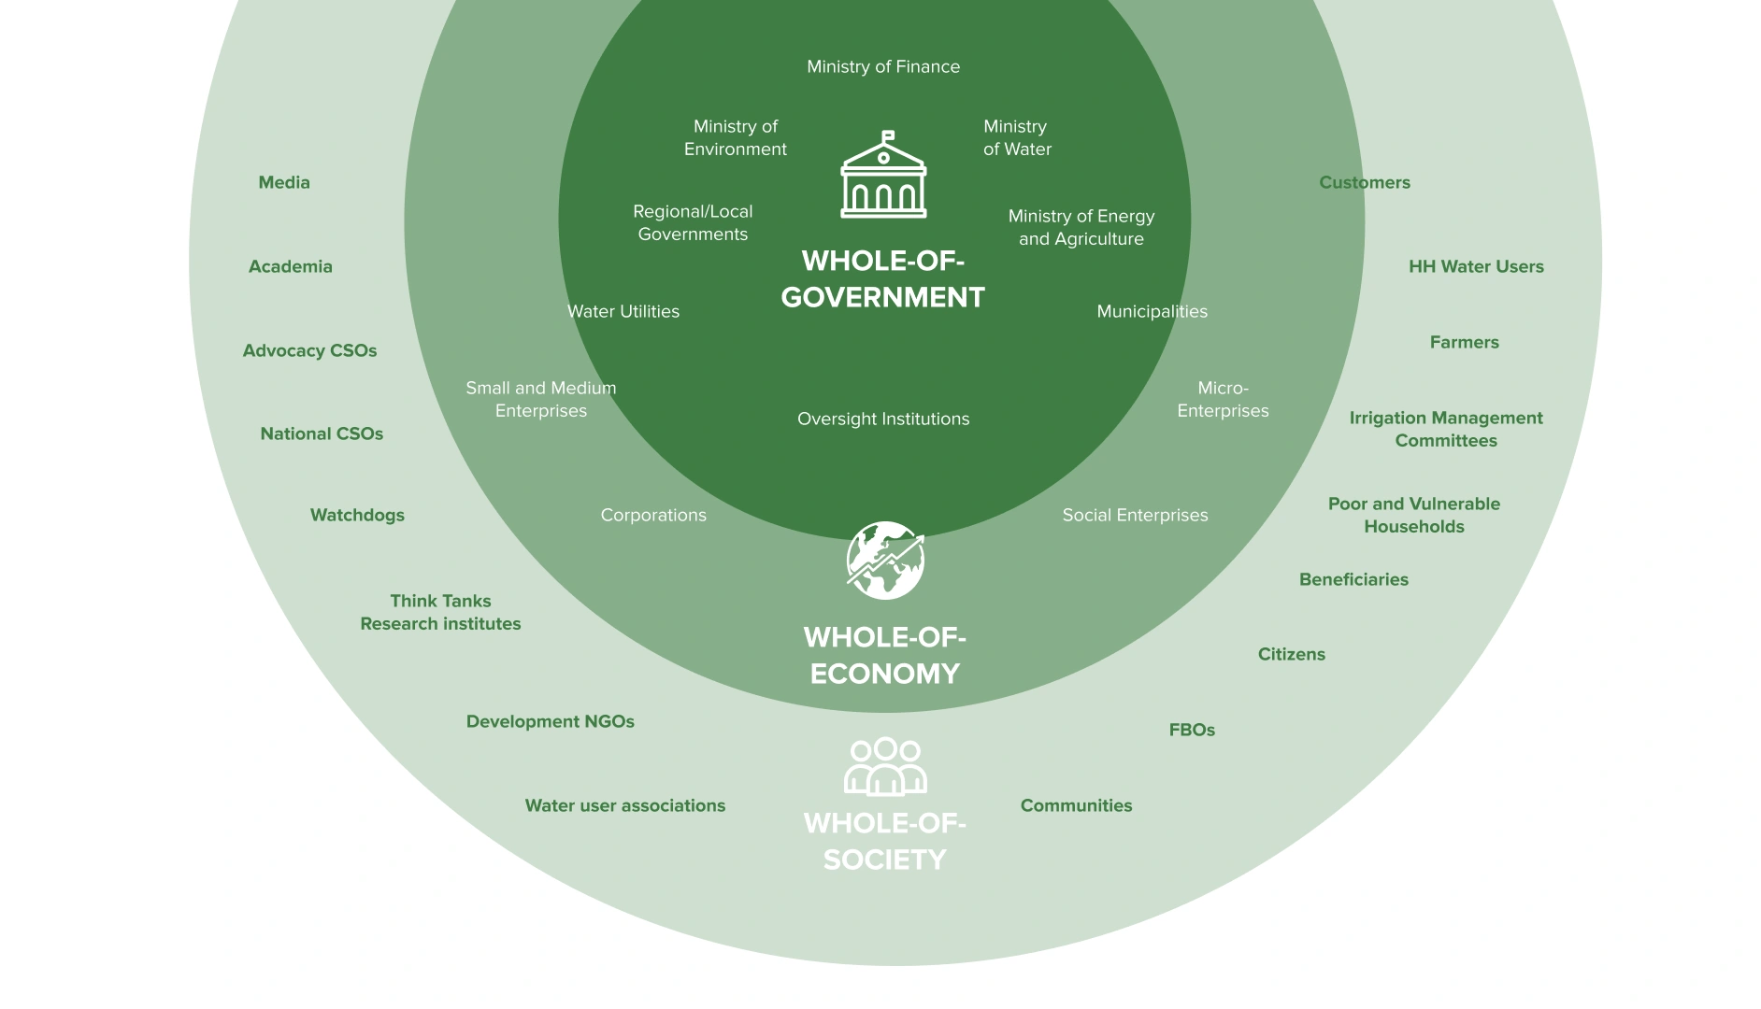
Whole-of-Society Approach
A whole-of-society approach 💬️ (WoS) to energy transition involves not just governments and energy companies but also policymakers, businesses, financial institutions, civil society, academia, Indigenous communities, and the general public, ensuring that diverse perspectives shape energy policies and projects.
This approach acknowledges that energy transition is not just a technological shift but a socio-economic transformation with far-reaching implications. This framework emphasizes inclusivity, shared responsibility, and systems thinking, ensuring that diverse voices—from governments to communities—shape energy policies.
By strengthening collaboration, it mitigates resistance, enhances public acceptance, and accelerates innovation. Additionally, the WoS approach prioritizes equity, reducing energy poverty and ensuring vulnerable groups benefit from clean energy systems. Its relevance lies in its ability to balance environmental goals with social and economic dimensions, creating a just and sustainable transition tailored to local and global needs.
M1: Introduction to Sustainable Energy System Transformation
B: Human Rights-Based Approach
What is it?
An approach emphasizing the fulfillment of human rights, shifting the focus from basic needs to rights.
How does it work?
It integrated human rights principles across all phases of development cooperation, aligns programming with international standards, and focuses on capacity building for both duty bearers and rights holders.
Why apply it?
It promotes equality, justice, and dignity for all, by addressing inequalities and discrimination at the root level. It empowers individuals and communities to claim their rights and enhances accountability and transparency in governance.
Human Rights-Based Approaches (HRBA) are deeply rooted in international human rights standards, aimed at safeguarding human rights within developmental landscapes. It emphasizes realizing human rights outlined in international agreements to rectify discriminatory practices and rebalance power dynamics hindering comprehensive development.
HRBA aims to foster equality, justice, and dignity beyond basic needs, transforming the narrative towards holistic rights fulfillment. It strengthens government capacities to honor rights obligations and empowers communities and individuals to claim their rights. Implementing HRBA entails integrating human rights principles across development stages, aligning programs with international standards, and capacity-building for duty bearers and rights holders.
Integrated throughout the project cycle, HRBA seeks to ensure program alignment with human rights principles from planning to monitoring, enabling redress for violations and fostering engagement. Its advantages encompass shifting focus from needs to rights, empowering stakeholders, enhancing governance transparency, addressing inequalities, and averting adverse human rights impacts, culminating in a framework prioritizing rights fulfillment and fostering equality, justice, and dignity for all (UNFPA, 2023) (UNSDG, 2023) (UNSDG, 2003).
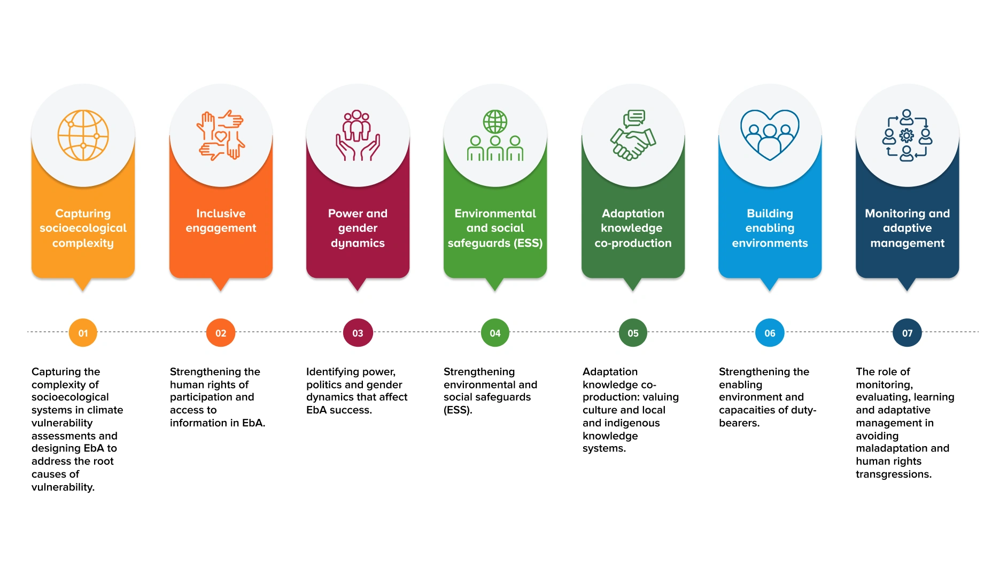
Main Human Rights-Based Approaches (HRBA)- Related Approaches Adopted
M1: Introduction to Sustainable Energy System Transformation
C: Gender Mainstreaming
What is it?
An approach that considers gender as an analytical variable, entailing a shift from gender-neutral to gender-responsive initiatives, policies, actions or processes.
How does it work?
Gender mainstreaming embodies the integration of a gender perspective across the entire spectrum of planning, implementation, monitoring, and evaluation within policies, programs, and actions spanning all sectors and levels.
Why apply it?
It promotes gender equality by identifying and addressing disparities, ensuring equal benefits from policies and programs, and promoting inclusivity.
Gender mainstreaming integrates a gender perspective into planning, implementation, monitoring, and evaluation across sectors and levels, ensuring women's and men's concerns become integral in initiatives to foster equality. Its core aim is to advance gender equality by identifying disparities and ensuring policies equally benefit both genders, eradicating discrimination.
This methodical approach analyzes policies for gender implications, addresses gaps using data, implements gender-responsive actions, and monitors progress through sex-disaggregated and gender indicators, incorporating gender perspectives at every stage.
Throughout the project cycle, from design to evaluation, gender mainstreaming ensures equitable program benefits, opposes discriminatory practices, amplifies initiative effectiveness through diverse perspectives, and aligns closely with the UN Charter's values of equality and inclusivity. (WEF, 2023) (UN, 2022) (UNIDO, 2021) (UNEP & EmPower, 2020) (UN Women & UNIDO, 2023).
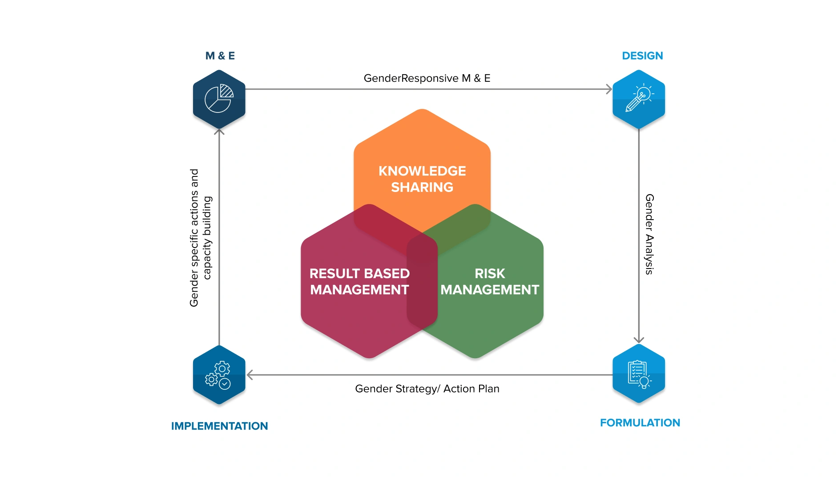
Mainstreaming gender issues at different stages of the project cycle
Data: The Gender Gap Report – World Economic Forum
The Global Gender Gap Report, initiated by the World Economic Forum in 2006, benchmarks gender parity in economic opportunities, education, health, and political leadership across 146 countries. It measures parity scores between men and women, with a score of 1 indicating full parity. The report aids strategic planning and policy by identifying disparities and trends, offering a vital tool throughout the project cycle for achieving global gender equality.
Indicators: Addressing Energy’s Interlinkages with other SDGs
The SDG 7 Policy Briefs compilation, "Addressing Energy's Interlinkages to Other SDGs" developed by the SDG7 Technical Advisory Group (SDG7 TAG), delves into how energy access intertwines with SDG 5 (gender equality), identifying potential indicators and assessing data availability. This report proposes a set of indicators to measure the gender gap in term of: access to electricity and clean cooking, employment and leadership, energy entrepreneurship 💬️, and the regulatory environment.
M1: Introduction to Sustainable Energy System Transformation
D: Intersectional Approach
What is it?
An intersectional approach to energy transition considers how overlapping social, economic, and environmental factors such as gender, race, income, and geography shape access to clean energy and its impacts.
How does it work?
By analyzing how energy systems intersect with power structures, it identifies exclusionary policies and redistributes decision-making authority. It integrates marginalized voices, particularly Indigenous communities, into policy design to address disproportionate vulnerabilities.
Why apply it?
Traditional energy transitions often replicate inequalities, worsening outcomes for women, low-income groups, and Indigenous populations. Intersectionality prevents universalist solutions that ignore localized disparities in resource access, labor roles, and climate resilience.
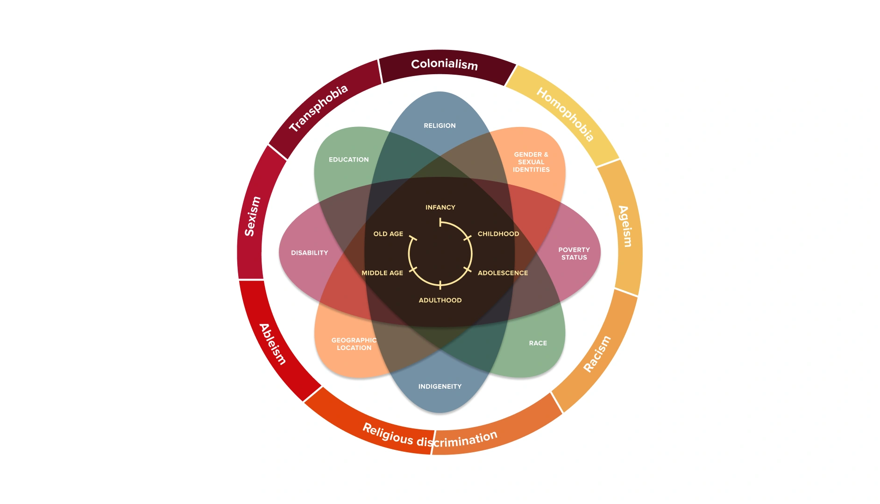
Intersectionality Wheel
This approach challenges traditional, Eurocentric models of energy by focusing on the power dynamics at play within energy systems. For example, in Latin America, legal frameworks often prioritize industrial permits over the land rights of Indigenous communities, which worsens climate-related displacement.
Looking through an intersectional lens helps us understand that energy poverty in marginalized communities 💬️ is not just about lacking infrastructure; it is also about how long-standing hierarchies shape who gets access to resources. Similarly, youth, as a dynamic and growing force, are critical to challenging these entrenched systems and advocating for energy policies that are inclusive and just. Youth engagement ensures that the voices of future generations are heard, particularly in communities most affected by energy inequality.
By embracing diverse knowledge systems, like Indigenous sustainability practices, we can rethink what a "just transition" looks like. This means empowering communities through participatory governance and co-creating policies that are adaptable and inclusive.
Which assumption is most fragile when leveraging cross-cutting approaches to drive systemic change in sustainable energy?
- Stakeholders will align their long-term goals with systemic change initiatives
- Policy frameworks will adapt swiftly to new integrated strategies
- Technological innovations will be compatible across sectors and regions
- Data sharing among actors will be transparent and secure
Key Takeaways
Four approaches, among many others, can revolutionize the way projects are designed, implemented, and evaluated, simultaneously addressing the world's primary challenges.
A whole-of-society approach integrates multiple stakeholders into decision-making, planning, and implementation processes, including inclusive policy development, public-private partnerships, and community engagement.
Gender mainstreaming is the recipe for gender equality, necessitating the consideration of gender as an analytical variable throughout the project, program or policy cycle.
A human rights-based approach ensures the fulfillment of people-centered goals, shifting the focus from basic needs to rights. An intersectional approach to energy transition considers how overlapping social, economic, and environmental factors such as gender, race, income, and geography shape access to clean energy and its impacts.
Key Resources
Intersectionality Resource Guide and toolkit
Gender Mainstreaming: A Global Strategy for Achieving Gender Equality and the Empowerment of Women and Girls
Leaving No One Behind: Equality and Non-Discrimination at the Heart of Sustainable Development

Lesson 1.4.2: Lesson 2: Addressing SDG7 Trade-offs for Sustainable Outcomes
Lesson
Addressing SDG7 Trade-offs for Sustainable Outcomes
M1: Introduction to Sustainable Energy System Transformation
Lesson 2 Overview
Efforts to expand access to sustainable energy—particularly under SDG7 and related targets—often involve complex trade-offs with other social, environmental, and economic goals. Advancing energy access can sometimes create tensions with objectives such as food security, water availability, environmental protection, or social equity.
This lesson explores how to recognize, evaluate, and manage these trade-offs in the context of sustainable energy systems. It highlights the importance of integrated planning, participatory decision-making, and context-specific solutions that aim to minimize negative impacts while maximizing co-benefits across the SDGs.
By examining real-world challenges—such as land use competition, environmental externalities of green technologies, and community-level equity concerns—this lesson encourages a systems-thinking approach to designing more balanced and resilient energy transitions.
Key Concepts
Explore foundational ideas from this lesson.
grid reliability
Grid reliability refers to the ability of an electrical grid to consistently deliver electricity to consumers without interruptions or failures.
low-carbon transport
Low-carbon transport refers to transportation methods and systems that produce minimal greenhouse gas emissions, often through the use of renewable energy sources, electric vehicles, public transit, cycling, and walking.
sustainable heating
Sustainable heating refers to methods of heating spaces that minimize environmental impact, often using renewable energy sources, energy efficiency practices, and low-carbon technologies.
M1: Introduction to Sustainable Energy System Transformation
A: Balancing Energy Affordability and Sufficiency
Increased access to affordable, reliable energy can inadvertently foster wasteful water consumption and overexploitation of resources, known as the "rebound effect".
Energy sufficiency and affordability pose challenges in transitioning to clean energy technologies, potentially leading to a return to polluting energy sources. A similar dilemma arises in clean cooking 💬️: high upfront costs and unreliable LPG supply hinder rural communities from abandoning biomass (UCL, 2021).
For instance, unconventional water supply options such as desalination are highly energy-intensive (ICSU, 2017), and this demand for energy can inadvertently exacerbate resource depletion. Similarly, certain agricultural practices that rely on energy-intensive technologies could also lead to unsustainable water use or land degradation. To mitigate these rebound effects, strategies such as energy sufficiency (ensuring that energy is used efficiently without waste), affordability mechanisms (making energy solutions financially accessible without overconsumption) and capacity-building (educating and training communities on sustainable energy use and conservation) have shown promise. (WBG, 2017; WLPGA, 2018).
Case Example: Advancing Energy Security and Livelihoods in Somalia
From 2016 to 2022, the United Nations Joint Programme for Sustainable Charcoal Reduction and Alternative Livelihoods (PROSCAL) addressed interlinked challenges of environmental degradation, energy insecurity, and poverty in Somalia. The initiative aimed to curb unsustainable charcoal production, trade, and use—major drivers of deforestation and instability—while simultaneously promoting alternative energy sources and livelihood opportunities.
Through a multi-pronged strategy, PROSCAL engaged key stakeholders, supported enforcement of charcoal trade bans, and invested in cleaner energy solutions such as fuel-efficient stoves, liquefied petroleum gas (LPG), and Mogadishu’s first biogas facility. The programme also promoted reforestation efforts and the transition to more sustainable charcoal production practices.
PROSCAL’s integrated interventions contributed to enhancing energy access, reducing environmental harm, generating local economic opportunities, and building resilience among vulnerable communities. By addressing the root causes of charcoal dependence, the programme helped mitigate conflict drivers and laid the groundwork for more sustainable peace and development in Somalia (source: UNDP).
M1: Introduction to Sustainable Energy System Transformation
B: Resolving Land Use Conflicts: Renewables vs. Food Security
More on this topic in Module 6.
Compared to conventional sources, renewable energy technologies often require more land, which can create tensions with ecosystem protection (SDG 15) and food security (SDG 2) in certain geographic contexts.
For instance, scaling up bioenergy 💬️ can conflict with efforts to manage forests sustainably, halt deforestation, and conserve biodiversity—especially when it involves monocropping for energy crops or large-scale solar installations. Historically, the global expansion of agrofuels (e.g., between 2005 and 2011) contributed to rising food prices by increasing competition for agricultural land, thereby reducing food affordability and access for vulnerable populations. Similarly, large-scale renewable projects such as hydroelectric dams have disrupted local economies—including agriculture and fishing—exacerbating food insecurity. These local land-use changes can also have ripple effects at the global level, highlighting the need for international coordination and integrated planning approaches.
Yet, multiple land uses and innovative solutions can help mitigate such trade-offs. Bioenergy stands out for its potential to serve as a co-benefit to land management, contributing to soil restoration, wildfire prevention, and habitat preservation (SDGs, 2022). Policies that promote bioenergy crop cultivation on degraded lands can support biodiversity and soil health while reducing pressure on global agricultural markets (ICSU, 2017).
Several case examples illustrate how integrated planning can reduce trade-offs. In Curitiba, Brazil, the "Solar Pyramid" project transformed landfills into solar power plants, supported by C40—a global network of mayors committed to climate action. In India, agrivoltaics has emerged as a promising integrated land-use solution, enabling the simultaneous production of food, electricity, and water (FAO, 2021; EUScienceHub,202)
Innovative Land Use for Urban Solar: Curitiba’s Solar Pyramid on a Former Landfill
The Solar Pyramid launched in 2023 in Curitiba is the Latin America's first solar plant on a former landfill, backed by the organization C40's cities. This landmark project demonstrates how cities can achieve clean, affordable energy while decreasing reliance on fossil fuels in their urban grids. The city primarily relies on hydroelectric power but faces energy shortages during droughts, resorting to fossil gas and coal plants. The Solar Pyramid supplies 8MW of energy capacity across Curitiba, slashing CO2 emissions by 90,000 tonnes (2020-2050), akin to removing 20,000 cars yearly. Additionally, it generates US$500,000 annually by substituting grid electricity with solar production (source: C40 Cities).
Scaling Agrivoltaics in India: Advancing Dual Land Use Through Policy and Innovation
Agrivoltaics, which is the dual use of land for solar energy 💬️ production and agriculture, is rapidly expanding globally, and India is initiating its adoption with over a dozen pilot projects nationwide. Research on Agrivoltaics in India led by the International Institute for Sustainable Development (IISD), evaluates the current development status, outlining challenges and opportunities for Agrivoltaics commercialization in India. The work aims to expedite adoption by offering policy recommendations, proposing business models, and providing a financial and technical transitions mechanism for state agencies, developers, and stakeholders (source: IISD).
M1: Introduction to Sustainable Energy System Transformation
C: Reducing the Environmental Footprint of the Renewable Energy Value Chain
The environmental sustainability of renewable energy systems depends not only on their carbon performance but also on their land and water footprints (SDGs 6, 14, and 15) across the entire value chain—from raw material extraction to infrastructure decommissioning.
The surge in demand for low-carbon technologies—such as solar panels, wind turbines, and battery storage systems—has intensified the extraction of critical minerals 💬️ like lithium, cobalt, and nickel. In 2023 alone, global battery storage capacity increased by 136% compared to 2022, and projections suggest a tenfold increase by 2030. These minerals now represent up to 5% of global revenues in the metals and mining sector. However, their extraction, refining, and transport often involve significant water use, generate toxic effluents, and pose risks to aquatic ecosystems, particularly in water-scarce regions. Modules 3 and 6 provide a deeper exploration of the critical mineral value chain and its environmental and social dimensions.
Beyond surface impacts, subterranean interventions such as borehole drilling and fracking can disrupt aquifers and geological stability, raising concerns about long-term water security. The environmental footprint of renewable systems must therefore be assessed holistically—considering life-cycle impacts on land and water across each stage of development. For example, while cadmium-based solar panels may require less land than silicon-based ones, their mining and waste disposal risks must be carefully evaluated (Our World in Data, 2022).
Water Security Challenges of the Clean Energy Transition
While the shift from fossil fuels to renewables generally reduces overall water consumption and decreases thermal and chemical pollution in aquatic environments, it does not eliminate water-related risks. In fact, poorly managed renewable technologies—such as hydropower, bioenergy, and green hydrogen—can strain water systems, particularly in arid or drought-prone regions (ICSU, 2017).
Increased water stress is already jeopardizing energy security in several parts of the world. In southern Europe, North Africa, and the Middle East, declining river flows have curtailed hydropower production, making power systems more vulnerable. For example, in 2021, a drop in hydropower output in Latin America led to increased reliance on liquefied natural gas 💬️, contributing to early price volatility.
Similarly, southern Europe’s reduced hydropower generation in 2022 exacerbated the ongoing energy crisis triggered by Russia’s invasion of Ukraine and the resulting gas supply disruptions (IEA, 2023).
These developments highlight the importance of integrated water-energy planning, robust environmental safeguards, and adaptive policies to ensure the clean energy transition contributes to long-term water and energy security.
M1: Introduction to Sustainable Energy System Transformation
D: Engaging Local Communities in Renewable Energy
The global demand for critical materials and large-scale infrastructure to fuel the energy transition offers opportunities for local industrial development and job creation—yet it also presents significant social and environmental risks (SDG 8). Renewable energy manufacturing and deployment can stimulate sustainable economic growth when paired with strong governance, but without safeguards, they may lead to worker exploitation, environmental degradation, and harm to affected communities.
National strategies such as export restrictions and industry nationalization aim to capture greater value from domestic resource endowments. However, these must be implemented through inclusive and rights-based frameworks that respect labor standards, uphold community rights, and safeguard ecosystems (IRENA, 2023). Large-scale projects—particularly hydropower and bioenergy installations—have been linked to disrupted land use practices, displacements, and violations of legitimate land tenure (SDG 1). Human rights abuses, including land grabs, threats to indigenous groups, and lack of compensation or remedy, underscore the urgent need for enforceable standards and grievance mechanisms (OHCHR, 2016) (CCSI, 2023). Instruments such as the UN Guiding Principles on Business and Human Rights provide a foundation for companies and states to prevent, address, and remedy harms (Amnesty, 2023).
To better understand and manage these risks, the International Renewable Energy Agency (IRENA) conducted a socio-economic footprint analysis of the energy transition in South Africa and Egypt. The analysis highlights the importance of evaluating renewable energy projects not only by their technical and financial performance, but also by their impacts on jobs, livelihoods, social cohesion, and environmental protection—promoting a more holistic and equitable energy transition.
Aligning Renewable Energy Development with Socio-Economic Inclusion in South Africa and Egypt
As part of its World Energy Transitions Outlook, the International Renewable Energy Agency (IRENA) conducted socio-economic impact assessments in South Africa and Egypt to inform inclusive energy transition planning and support evidence-based policymaking.
In South Africa, one highlighted initiative involves a wind energy 💬️ project that catalyzed the creation of a small-to-medium enterprise (SME) focused on bird monitoring. This initiative not only addressed biodiversity concerns associated with wind infrastructure but also generated professional opportunities for members of historically disadvantaged communities. By integrating environmental safeguards with local capacity-building, the project demonstrates how renewable energy development can contribute to both ecological protection and social equity.
These findings emphasize the importance of embedding socio-economic co-benefits into energy transition strategies—ensuring that the shift to renewables enhances livelihoods, supports local enterprises, and promotes inclusive development outcomes (source: IRENA).
Key Takeaways
Sustainable energy transitions involve complex trade-offs that can impact food security, water resources, land use, and social equity. Navigating these requires integrated and context-specific planning approaches.
Large-scale renewable energy projects may generate unintended environmental and social impacts, such as biodiversity loss, land conflicts, and water stress—especially in vulnerable regions—underscoring the need for thorough life-cycle and impact assessments.
Balancing competing priorities requires transparent decision-making, stakeholder engagement, and adaptive policies that anticipate synergies and minimize negative consequences across the SDGs.
Key Resources
Implementing the Water–Energy–Food–Ecosystems Nexus and Achieving the Sustainable Development Goals
Integrating the Three Dimensions of Sustainable Development - A Frameworks & Tools
Life Cycle Assessment in Renewable Energy: Solar and Wind Perspectives

Lesson 1.4.3: Lesson 3: Scaling Strategies that Enable Equitable Energy Transitions
Lesson
Scaling Strategies that Enable Equitable Energy Transitions
M1: Introduction to Sustainable Energy System Transformation
Lesson 3 Overview
Implementing energy transition strategies requires navigating complex decisions around costs, trade-offs, and long-term impacts. This lesson explores practical approaches to scaling solutions that accelerate decarbonization, improve energy efficiency, and promote equity.
Key considerations include balancing the upfront costs of energy efficiency measures with long-term economic and environmental benefits, and addressing potential tensions—such as those between modern upgrades and the preservation of historical or cultural sites. The lesson also examines ecosystem-based planning, sustainability education, and nature-based solutions 💬️ as tools for building inclusive and adaptive energy systems.
By focusing on implementation strategies that are locally relevant, socially inclusive, and environmentally sound, this lesson equips learners with the knowledge to support resilient and people-centered energy transitions.
M8: Renewable Energy Technologies and Innovations
A: Adopting An Ecosystem Approach
Achieving and sustaining any development outcome of renewable energy innovations depends on the ability of multiple and interconnected actors – governments, civil society, the private sector, universities, individual entrepreneurs and others – to work together effectively. Each set of interconnected actors whose collective actions produce a particular development outcome is a local system (or ‘ecosystem’). Improving that development outcome therefore requires an ecosystems approach.
Although innovation is a means to improving how development goals are achieved rather than an outcome in itself, the same principles apply. For innovative ideas to be efficiently generated, developed, tested and ultimately scaled for development impact they also require the coordinated, collaborative action and resources of the actors noted above – collectively referred to as the ‘innovation ecosystem’.
Innovation ecosystems can operate at multiple levels (e.g. city, regional, national) and within multiple sectors (e.g. agriculture, health, education). Because of this breadth, it can be difficult to draw meaningful boundaries around who is or isn’t part of an innovation ecosystem. It is therefore helpful to focus first on the sector and problem that the innovation is seeking to address (e.g. “low attendance rates among girls at government-run primary schools in Nairobi”) and then consider the specific actors, resources and contextual factors that the innovation will need to engage, utilise or influence to be impactful.
Adopting an ecosystems approach to innovation recognizes that:
An innovation ecosystem is made up of different actors, relationships and resources who all play a role in taking a great idea to transformative impact at scale.
The effectiveness of each part within the innovation ecosystem is moderated by other parts of the system (e.g. entrepreneurs depend on being able to access financing).
A change to one part of the innovation ecosystem leads to changes in other parts of the innovation ecosystem (e.g. an increase in internet connectivity will accelerate the design and testing of new technologies).
Innovation ecosystems can operate at multiple levels (e.g. city, regional, national) and within multiple sectors (e.g. agriculture, health, education). Because of this breadth, it can be difficult to draw meaningful boundaries around who is or isn’t part of an innovation ecosystem. It is therefore helpful to focus first on the sector and problem that the innovation is seeking to address (e.g. “low attendance rates among girls at government-run primary schools in Nairobi”) and then consider the specific actors, resources and contextual factors that the innovation will need to engage, utilise or influence to be impactful.
The process of developing, testing and scaling innovation for sustainable impact cannot be undertaken by any one actor working in isolation. The support of a wide range of actors (including technical, financial and political support from local, national and sometimes international entities) across the value chain is typically required to successfully progress any innovation across the six stages of scaling identified by IDIA, as shown below.
M1: Introduction to Sustainable Energy System Transformation
B: Promoting Sustainability Education and Behavior Change
Effective achievement of energy efficiency 💬️ goals demands broad cooperation (SDG 17) and requires education on sustainability (SDG 12).
Creating widespread awareness and understanding among governments, industries, and communities is paramount for an initiative’s success (WEF, 2023). While technology is essential, influencing consumer behavior significantly impacts energy savings. For instance, smart metering and real-time feedback systems have been shown to reduce household energy consumption by 5-15%.
Behavioral approaches can reshape energy efficiency programs by integrating social norms, incentives, and nudging techniques. An example is the "Cool Biz" campaign in Japan, which encourages businesses to relax dress codes and reduce air conditioning use, has saved an estimated 1.4 million tons of CO₂ emissions annually. In India, the Unnat Jyoti by Affordable LEDs for All (UJALA) program leveraged bulk procurement and behavioral campaigns to distribute over 360 million LED bulbs, reducing annual electricity consumption by 47 billion kWh.
Successful energy efficiency initiatives require a mix of technology-driven solutions and a deep, contextual understanding of human behavior. This emphasizes tailored, cost-effective approaches, continual evaluation, and engagement with communication experts in crafting effective behavior change campaigns. Behavioral approaches can reshape energy efficiency programs, focusing on behavior change and gender equality. These programs need to consider local contexts and consumer data, possibly integrating them into broader interventions (UNDP, 2024; ESMAP, 2020).
Education on energy efficiency encourages the development of technologies that minimize energy wastage and promotes collaborative research into renewable and clean energy resources (UNESCO, 2023). UNICEF’s Climate Change Strategy highlights the role of education in raising awareness and fostering youth-led climate action. For instance, UNICEF's "Green Skills for Youth" initiative trains young people in sustainable practices, equipping them with the knowledge and skills to implement energy efficiency measures in schools and communities. Overcoming challenges involves inclusive capacity-building efforts across sectors, focusing on individuals regardless of age or gender, particularly targeting women and youth (SDG 5) (FAO, 2020).
Beyond education and behavior change, financing mechanisms play a crucial role in scaling energy efficiency. Governments and financial institutions have introduced innovative financing 💬️ models such as green loans, energy service companies (ESCOs), and on-bill financing to encourage businesses and households to invest in energy-efficient solutions.
More on energy financing in Module 4.
M1: Introduction to Sustainable Energy System Transformation
C: Scaling Nature-Based Solutions to Advance Equality and Land Stewardship
Nature-based solutions (NBS) stand as a promising avenue for scaling up energy efficiency by leveraging ecosystems to regulate temperatures, enhance insulation, and reduce energy demand in buildings and infrastructure.
For instance, urban green infrastructure, such as green roofs and tree-lined streets, lowers cooling costs by mitigating the urban heat island effect, while wetland restoration can enhance water retention and reduce the energy needed for water treatment and distribution. In agriculture, agroforestry and regenerative farming improve soil moisture retention, reducing irrigation-related energy consumption.
However, the substantial land requirements of large-scale nature-based solutions, especially for climate change mitigation (i.e. carbon capture solutions), require simultaneous actions to ease land pressure, such as shifts in food systems and agriculture, to prevent potential conflicts.
Inclusive design becomes critical considering the historical impact on marginalized communities 💬️ amid land and climate changes. Challenges to wider adoption include limitations in ecosystem services, monitoring difficulties, and varying societal perceptions of climate risks (WWF, 2020). Mitigating potential trade-offs and avoiding exacerbating climate issues and social injustices require integrated, bottom-up approaches. UNDP's initiatives, particularly in tackling deforestation through nature-based solutions, exemplify this comprehensive strategy.
In Angola, where 88% of the multidimensionally poor live in rural areas threatened by deforestation and unsustainable energy practices, the UNDP is partnering with the national government to address intertwined environmental and social challenges. Under Angola’s 2020–2022 development priority on natural resource management, UNDP supports a nature-based, integrated approach to curb deforestation and forest degradation.
The strategy emphasizes community-based forest management and the transformation of the charcoal value chain, aiming to improve both environmental outcomes and rural livelihoods. Key interventions include promoting sustainable charcoal consumption practices in urban areas and embedding sustainability criteria into government energy policies. These efforts not only foster long-term ecosystem resilience but also contribute to poverty reduction and inclusive rural development (source: SDG).
As countries and communities navigate the complexities of transforming their energy systems, success will depend not only on innovation and investment, but also on the ability to integrate cross-cutting approaches, manage trade-offs, and scale context-sensitive strategies such as nature-based solutions.
With Chapter 4, we have explored how to operationalize the energy transition through inclusive, adaptive, and system-wide action.
The rest of the Academy will build on these foundations, diving deeper into approaches, tools, financing mechanisms, and governance frameworks that can drive sustainable energy transformation across diverse regional and policy contexts.
Which strategy best promotes equitable energy transitions across diverse communities?
- Implementing inclusive policy frameworks that prioritize marginalized groups
- Expanding clean-energy technologies first and addressing equity mainly through later affordability measures
- Offering broad electricity price subsidies to lower bills, without targeting support to the most vulnerable
- Prioritizing infrastructure expansion with limited co-design, relying on national plans to determine local priorities
Key Takeaways
Adopting an ecosystem approach enables innovation to scale by fostering collaboration among governments, communities, private actors, and civil society—ensuring that renewable energy solutions are context-driven and supported across the entire value chain.
Behavior change and sustainability education are essential complements to technology, shaping long-term energy use patterns and empowering individuals and institutions to act effectively on energy efficiency goals.
Nature-based solutions can enhance energy resilience and equity, but their success depends on inclusive design, careful land-use planning, and integration with broader social and environmental strategies.

Lesson 1.4.-1: Chapter 4 Outro

Chapter 1.-1: Module 1 Outro

Lesson 1.-1.0: Module 1 Quiz
Scored quiz
Module 1
This quiz covers all the lessons in this module. You must achieve 80% to pass. Good luck!
What percent of global greenhouse gas emissions can be attributed to energy production and use?
- 0.75
- 0.9
- 0.6
- 0.3
Correct
Energy is the dominant contributor to climate change, so much so, that reaching zero carbon emissions is dependent on an energy transition and leapfrogging historic energy development pathways.
Incorrect
What relationship does energy have with HDI?
- More energy increases human development
- Human development increases energy production and consumption
- Both 1 and 2
- Neither option is correct
Energy and HDI have a relationship similar to the chicken and the egg - it is unclear which factor influences the other, disproving a causal relationship. However, we know that increased energy consumption leads to higher HDI, and higher HDI leads to increased energy production and consumption.
How does energy access increase gender equality?
- Reducing time poverty for women and girls
- Increasing men's employment opportunities in the renewable energy sector
- Increasing security for women and girls
- Both A & C
Women and girls are believed, in some regions, to be spending up to 18 hours weekly on wood gathering and household cooking (UNDP, 2022). Therefore, access to clean energy directly aids in reducing women's time poverty. Public outdoor lighting increases security for women and girls, allowing more autonomy after dark and reducing exposure to gender-based violence.
How efficient is the global energy system?
- 1
- 0.93
- 0.55
- 0.37
The current global energy system operates at only 37% efficiency (RMI, 2019), meaning that nearly two-thirds of the primary energy produced is lost due to inefficiencies in generation, transportation, and end-use.
What is the largest source of renewable energy in the Arab States region?
- Solar PV
- Hydropower
- Nuclear
- Natural gas
Hydropower plays a dominant role in the Arab States. While 7% of power flows from renewable sources, about 3.4% comes specifically from hydropower. It has the largest installed capacity at 11.2 GW.
Which region has the largest energy access gap?
- Asia-Pacific
- Europe and Central Asia
- Africa
- Arab States
Africa is the region with the largest gap in energy access. With over 80% of Africa’s unelectrified population in rural areas, off-grid and decentralized renewable energy solutions can both grant access and leapfrog traditional development pathways.
Which renewable energy export from the Eastern Europe and Central Asia region could be positively affected by the EU's Carbon Border Adjustment Mechanism?
- Wind
Hydrogen presents a growing energy opportunity for the RBEC region, despite currently negligible export levels under the chemicals category. With the EU’s Carbon Border Adjustment Mechanism (CBAM) increasing costs for carbon-intensive exports, there is strong incentive to decarbonize. EU initiatives like REPowerEU are supporting countries such as Moldova, Ukraine, and those in the Western Balkans to invest in producing and trading clean fuels, including renewable hydrogen, positioning hydrogen as a critical future export and energy solution to meet rising EU demand
Who would be included in a whole-of-society approach to the energy transition?
- Academia
- Farmers
- Government
- All of the above
A whole-of-society approach (WoS) to energy transition involves not just governments and energy companies but also policymakers, businesses, financial institutions, civil society, academia, Indigenous communities, and the general public, ensuring that diverse perspectives shape energy policies and projects.
What is a key reason that increased investment in resilient energy infrastructure is essential for Caribbean countries?
- To reduce internet costs
- Because they have stable weather conditions
- To lower fossil fuel production
- Because natural disasters frequently damage energy systems
Caribbean states spend up to 1.2% of GDP on natural disaster recovery annually. Resilient infrastructure – especially solar mini-grids – can protect critical services during disasters.
Why is the development of green hydrogen considered a major opportunity for countries like Chile, Uruguay, and Brazil?
- These countries lack other renewable energy sources
- Green hydrogen reduces fossil fuel subsidies
- It allows for energy storage and clean export industries
- It eliminates the need for wind and solar power
Green hydrogen can be produced using abundant low-cost solar and wind resources in these countries and then exported as a clean fuel

Lesson 1.-1.-1: Module 1 Outro

